Accessing JSTOR during school hours.

Enter the URL:- http://www.jstor.org/. Under the JSTOR logo you should see ‘Your access to JSTOR provided by Chelmsford County High School for Girls’. This allows CCHS to access content. If you don’t see this then access is denied.
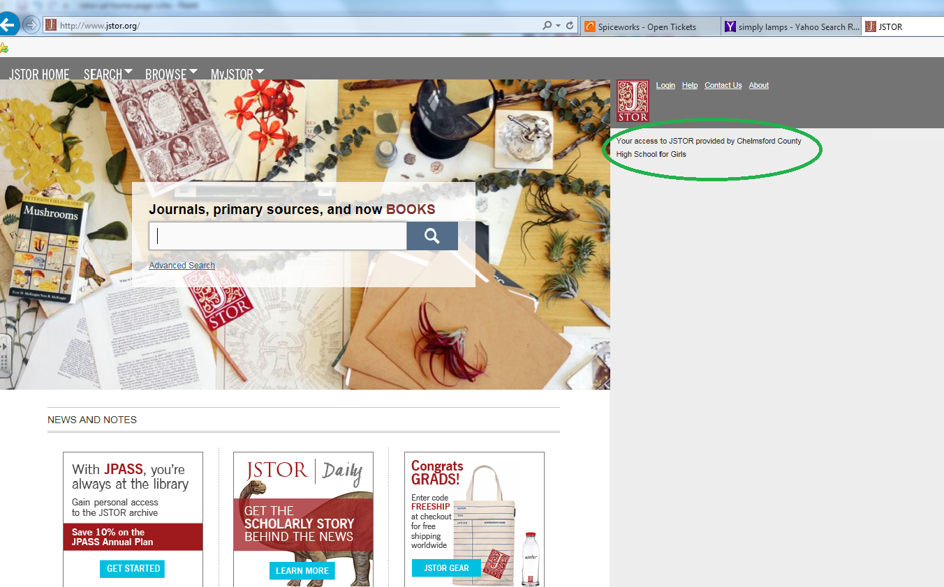

To access any content in the search bar type what you are looking for e.g. ‘ Mockingbird
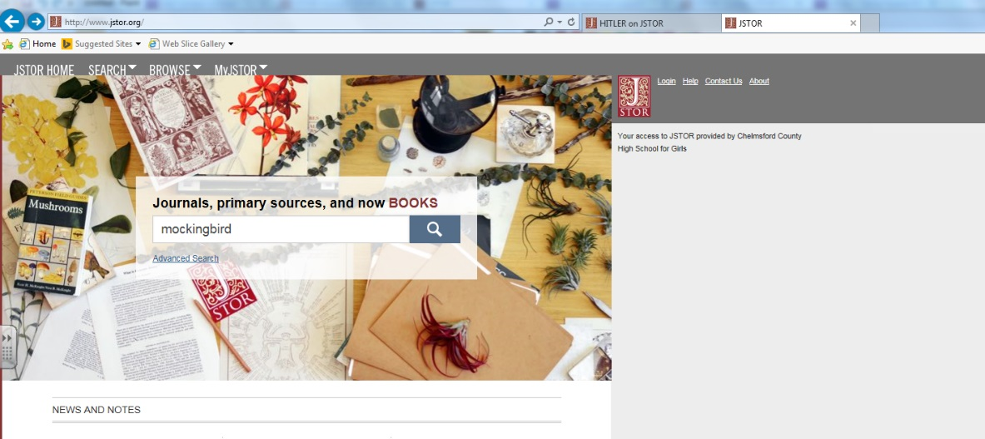
This particular search finds 5,843 documents with the word ‘Mockingbird’. It’s best to narrow your search criteria if you know exactly what you are attempting to find.

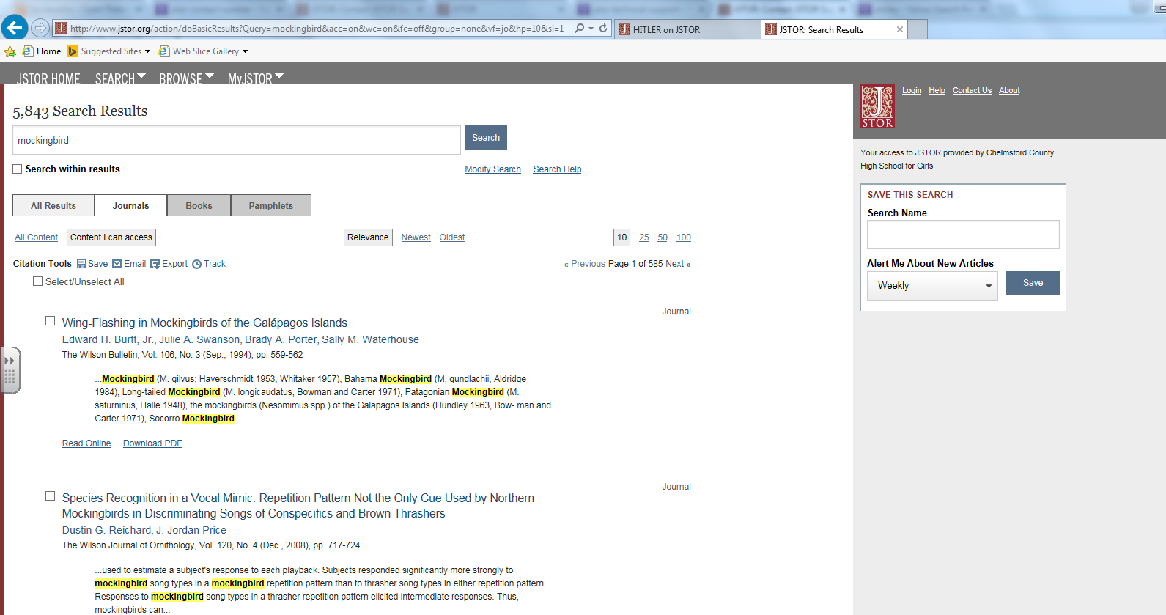

Accessing JSTOR on a computer at home.
Students will need to click on the token link:-https://www.jstor.org/token/ftc6JqeViNsn8KqqQG3x/cchs.co.uk the first time they use MyJSTOR to access it from off site. If they already created a MyJSTOR account, they can simply login once they click the token and the token will then be attached to their account.

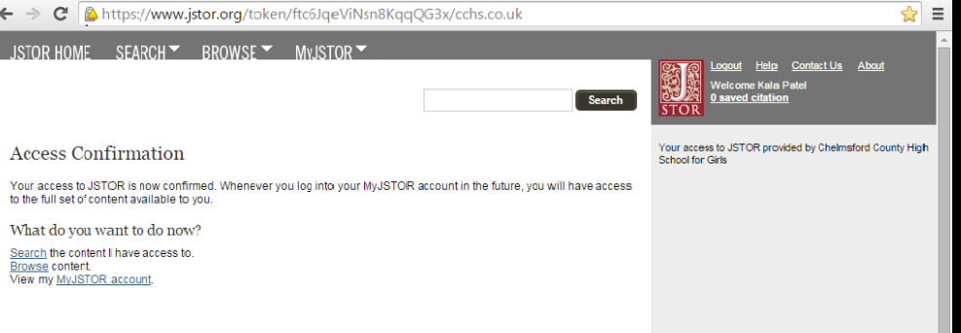

If they have not yet created a MyJSTOR account, clicking on "Register" after following the token link will allow them to create an account that is functional off site.
