ART – ‘Society’

The transition from GCSE to Advanced Level is not easy. To help you with this, it is important to make sure that your observational drawing skills are up to a high standard. By completing the following tasks, you should be able to improve your drawing standards to the best of your ability at the present time.

Advanced Art homeworks should take you about 3-4 hours per week, which sounds like a phenomenal amount of work but remember that you are doing less subjects.

Your holiday tasks are:

Task 1 - A creative response to ‘Society’ – you can use a combination of photography and /or film, mixed media, text, drawn, painted, textiles or drawn images to respond to this theme in 2D or 3D.
Produce one A3 page of 4 annotated mini-ideas and a final piece on A3 or a 3D piece that is a size of your choice.

Task 2 – An observational drawing of a tap and towel showing two contrasting textures.
A4 pencil drawing; to show the difference in surface texture
Example below:

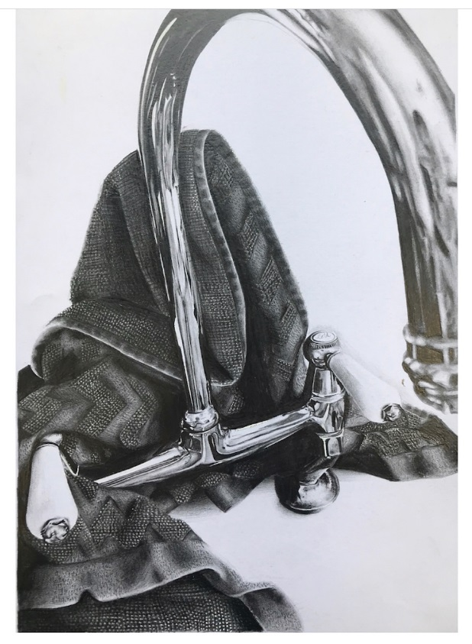
Whilst we do not want to put you off doing the subject, it is important to remember that real commitment to the subject will help you attain the highest grade possible, and we therefore want the holiday work to be done with the same amount of time spent on it as an actual homework. This obviously means starting straight away as you cannot rush it and get Advanced Level results.

When you return to school in September you will bring the two pieces of work with you, and they will be marked to the appropriate criteria. The studies will be part of your coursework and go towards your final grade. Do not try to start the course without them.

In addition to these set pieces, we would like you to visit an Art Gallery or exhibition and working in a sketchbook, complete two sketches of the pieces you like most. Then add some notes about your chosen pieces and the whole exhibition, explaining your own personal thoughts and feelings. You should include any pamphlets or postcards that you are able to acquire. Obviously in the current climate this will be very difficult so maybe take a digital tour of an exhibition or even explore some websites.

Your teachers this year will be Mr Harvey and Mr Bradford. We try hard to make the course as varied and interesting as possible.

Finally, we hope you enjoy your two years!

Mr Harvey
(Head of the Creative Faculty / Head of Art)
jharvey@cchs.co.uk

