GCSE (9-1) Biology

A Level Biology A & B

Language of Measurement in Context

The purpose of this exemplar investigation is to illustrate the use of the language of measurement terms in the context of a Biology practical activity.

Hydrogen peroxide and catalase
In this practical, a student investigates the effect of hydrogen peroxide concentration on the rate of reaction of the catalase, using potato cylinders.

Practical activity
The enzyme catalase is found in plant and animal cells. It catalyses the breakdown of hydrogen peroxide into water and oxygen.
catalase
hydrogen peroxide water + oxygen
catalase

2H₂O₂ 2H₂O + O₂
Five different concentrations of hydrogen peroxide (3.0%, 2.5%, 2.0%, 1.5%, 1.0%) are prepared. The student produces fifteen potato cylinders using a cork borer. These are used as the source of catalase. The cylinders are cut to 50 mm in length, measured using a ruler, as shown in Fig. 1.
Fig. 1 shows a systematic error when measuring the length of the potato cylinder with a ruler. The student has not measured using the zero mark on the rule. Systematic errors are consistent repeatable errors involving equipment.
Random error is always present in a measurement. Taking more repeat measurements and calculating a mean can reduce the effect of random error. A random error can be a sudden change in room temperature, which can affect the rate of the enzyme-controlled reaction.
Potato cylinder

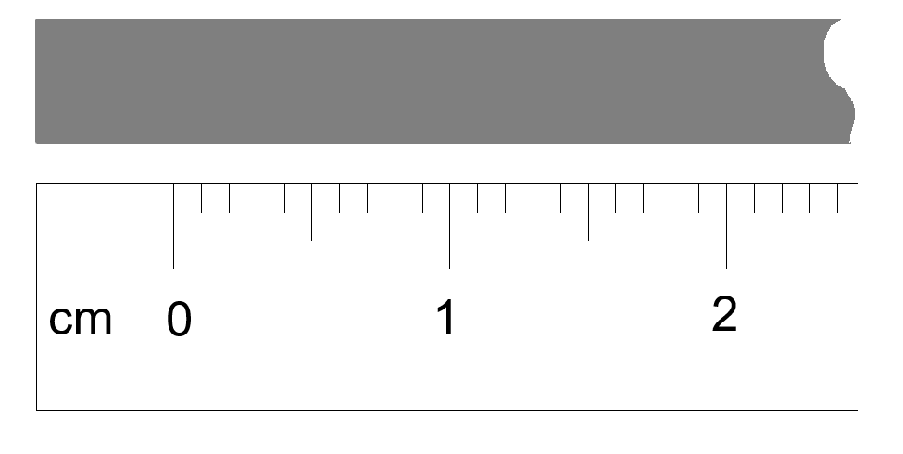

Ruler

Fig. 1
The apparatus is set up as shown in Fig. 2.
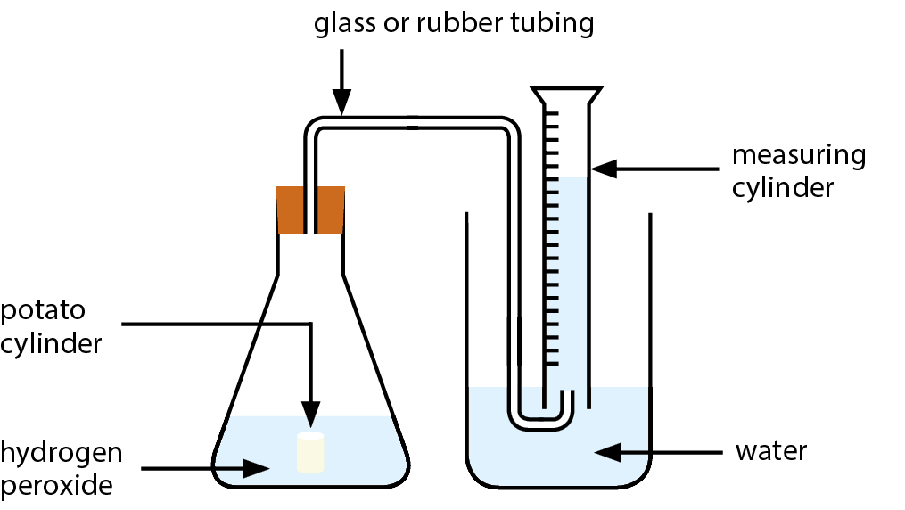
Fig. 2
The student drops the potato cylinder into the conical flask with the 20 cm³ of 1.0% hydrogen peroxide and starts the stopwatch. The volume of oxygen produced at 3 minutes, is measured.
The independent variable in this practical is the concentration of hydrogen peroxide. This is because the student carrying out the practical is directly changing the concentration.
The dependent variable is the volume of oxygen produced in 3 minutes, because this has been directly affected by the change of the independent variable.

At the end of the 3 minutes the student reads from the measuring cylinder as shown in Fig. 3. The student recorded it as 2.8 cm³ .
Control variables include:
- the fixed volume of hydrogen peroxide,
- length of potato cylinder (Which is effectively concentration and volume of enzyme),
- and time to collect the oxygen:
NOTE in this experiment time is a control variable as they are seeing the volume of gas produced in a fixed time.
If they were measuring volume of gas every minute you would probably not state that time was a control variable.
They are kept the same each time to ensure they do not influence the dependent variable.
To ensure validity, control variables need to be identified and kept constant. In this way other variables do not influence the dependent variable.
When using apparatus with an analogue graduated scale, the uncertainty in a single measurement is typically taken to be ± half the smallest graduation, in this case 0.1 cm³.
A change in the volume of oxygen in the measuring cylinder involves two readings. The absolute uncertainties for each reading must be added to give the absolute uncertainty in the combined measurement. So, the absolute uncertainty is:
2 x 0.1 cm³ = 0.2 cm³
Note: Due to the ambiguity in some textbooks, in exams we will accept both the half and the smallest division as the absolute uncertainty.
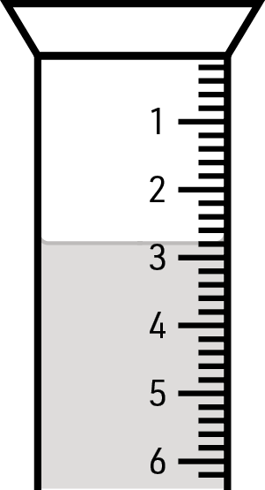
Fig. 3

Another student uses a gas syringe to measure the volume of oxygen produced. For the same concentration of hydrogen peroxide, they record 2.85 cm³.
The gas syringe has smaller graduations, so has a higher resolution. Higher resolution instruments measure smaller changes.

The student repeats the practical 3 times, using the same volume of hydrogen peroxide and the same length of the potato cylinder, for each hydrogen peroxide concentration.
Results are repeatable if the use of the same equipment, same method, and same experimenter gives similar results. Repeating results can also reduce random errors and allow precision to be determined. The term ‘reliable’ should not be used, as its meaning is unclear.

Results
Just repeating the practical does not improve accuracy. The accuracy is influenced by both systematic and random errors.
H₂O₂ conc.(%) | Volume of oxygen collected after 3 minutes (cm³) |  |  |  | Mean rate of oxygen released (cm³ min⁻¹)
 | Trial 1 | Trial 2 | Trial 3 | Mean
3.0 | 6.8 | 7.0 | 6.7 | 6.83 | 2.28
2.5 | 5.0 | 5.3 | 5.5 | 5.27 | 1.76
2.0 | 4.8 | 4.5 | 4.4 | 4.57 | 1.52
1.5 | 4.0 | 4.2 | 4.1 | 4.10 | 1.37
1.0 | 2.8 | 4.3 | 2.5 | 3.20 | 1.07
The repeat measurements are close together, although there is variation. We can say the precision of the measurements is good.
Repeating the practical will allow you to identify an anomalous result. If you record the suspected anomaly due to an error or due to different conditions, then calculate the mean without the anomalous result. If you identify the anomaly during the practical, then you might consider repeating the practical.

Repeating the practical will allow you to identify an anomalous result. If you record the suspected anomaly due to an error or due to different conditions, then calculate the mean without the anomalous result. If you identify the anomaly during the practical, then you might consider repeating the practical.
The student compared their results with the results from another group of students.
H₂O₂ conc. (%) | Mean volume of oxygen collected after 3 mins (cm³)
3.0 | 6.50
2.5 | 5.41
2.0 | 4.20
1.5 | 4.08
1.0 | 3.15
The student concluded that their results are reproducible.
Similar results obtained by other groups indicate that the results are reproducible. This is a test of the quality of the data.

Notes:
- This resource is in the style of a GCE practical, but many terms apply to GCSE too.
- The words in bold are explained further in the ‘Glossary of Terms’
.

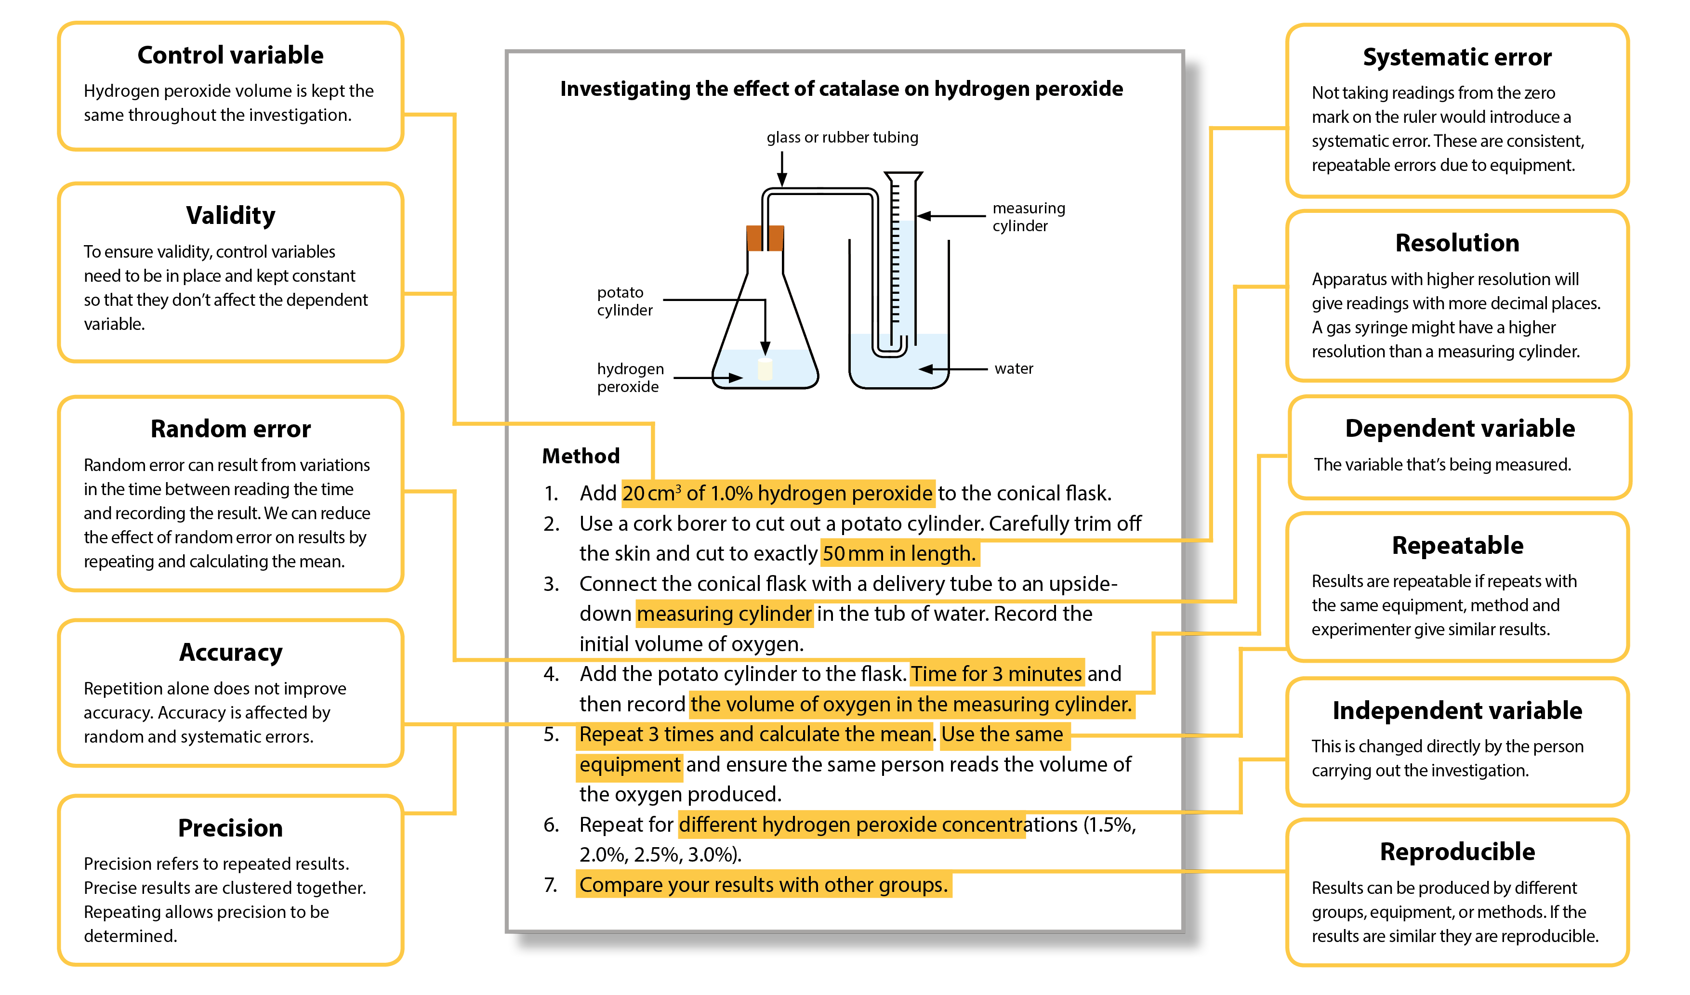

Glossary of terms
Term | Definition | Notes
accuracy | a measurement result is considered accurate if it is judged to be close to the true/acceptable value | Accuracy is a property of a single result. Random and systematic errors reduce accuracy.
anomaly (outlier) | value in a set of results that is judged not to be part of the inherent variation | Calculate the mean without the anomaly if you suspect an anomaly due to an error or due to different conditions.  If you identify an anomaly during the practical, then consider repeating the measurement.  In Maths, you may use the term ‘outlier’.
control variable | variables other than the independent and dependent variables which are kept the same | These are quantities or conditions that are kept the same in a practical. Changes in these conditions could affect the validity of your method and results.
dependent variable | variable which is measured whenever there is a change in the independent variable | The dependent variables are recorded as either numerical values with units (quantitative) or in the form of descriptive comments (qualitative).
independent variable | variable which is deliberately changed or selected by the person in the planning of a practical activity | The independent variable is recorded in the first column of a results table.  The dependent variable is recorded to the right with processed data in the far-right columns.  In a graph, the independent variable is usually plotted on the x-axis with the dependent variable on the y-axis.
line of best fit | a line drawn on a graph that passes as close as possible to the data points. It represents the best estimate of the underlying relationship between the variables. | A line of best fit can be a straight line or a curve.  This differs from GCSE Maths, where a line of best fit is always a straight line.
precision | a quality denoting the closeness of agreement between measured values obtained by repeated measurements | Precision refers to more than one value. Precise results are clustered together. You can only determine if your results are precise by repeating the measurement.  Reducing the effect of random errors improves precision. A systematic error does not affect precision, as it is the same error each time. You may have precise results with a systematic error, but not accurate results.
random error | error in a measurement due to small uncontrollable effects | We can’t correct random errors, but we can reduce their effect by making more measurements and calculating the mean. Random errors contribute to uncertainty.
range (of a variable) | the maximum and minimum values of the independent or dependent variables | In Maths the range is the difference between the biggest and smallest value of a variable.
repeatability | precision obtained when measurement results are produced in one laboratory, by a single operator, using the same conditions, over a short timescale | A measurement is repeatable when repetition under the same conditions gives similar results.  Anomalous results can be identified by repeating the measurement. However, never discard data simply because it does not correspond with expectations.
reproducibility | precision obtained when measurement results are produced by different laboratories and therefore by different operators using different pieces of equipment | A measurement is reproducible when similar results are produced by different groups or different equipment or altered methods. If the results are reproducible then you can be more confident in the quality of the results.
resolution | smallest change in the input quantity being measured by a measuring instrument that gives a perceptible change in the reading of the measuring instrument | For example, the resolution of a ruler is 1 mm and the resolution of a burette is 0.1 cm³. It is not correct to describe equipment with a higher resolution as being more precise, as precision is a property of repeated results.
systematic error | error due to the measured value differing from the true value by the same amount each time | Methods or equipment may introduce systematic errors, producing consistent errors in results. Using the same equipment each time avoids introducing more systematic errors. Calibrating equipment where appropriate reduces systematic errors.  A zero error is when the measuring device indicates a value when the quantity being measured is zero.  Systematic errors contribute to uncertainty.
uncertainty | interval within which the true value can be expected to lie, with a given level of confidence or probability | Uncertainties depend on a range of factors, including systematic and random errors. Analogue apparatus typically has an uncertainty of ± half the smallest graduation. The uncertainty of the digital apparatus is ± the resolution of the apparatus.
validity (of an experiment) | suitability of the method used to answer the question being asked | To ensure validity, identify control variables and keep them constant to avoid affecting the dependent variables.  In the case of field studies there are naturally changing variables. Ensure the control variables are as similar as possible when repeating.

We’d like to know your view on the resources we produce. Click ‘Like’ or ‘Dislike’ to send us an auto generated email about this resource. Add comments if you want to. Let us know how we can improve this resource or what else you need. Your email will not be used or shared for any marketing purposes.
Looking for another resource? There is now a quick and easy search tool to help find free resources for your qualification.
OCR is part of Cambridge Assessment, a department of the University of Cambridge.
For staff training purposes and as part of our quality assurance programme your call may be recorded or monitored.
Oxford Cambridge and RSA Examinations is a Company Limited by Guarantee. Registered in England. Registered office
The Triangle Building, Shaftesbury Road, Cambridge, CB2 8EA. Registered company number 3484466. OCR is an exempt charity.
OCR operates academic and vocational qualifications regulated by Ofqual, Qualifications Wales and CCEA as listed
in their qualifications registers including A Levels, GCSEs, Cambridge Technicals and Cambridge Nationals.
OCR provides resources to help you deliver our qualifications. These resources do not represent any particular teaching method we expect you to use. We update our resources regularly and aim to make sure content is accurate but please check the OCR website so that you have the most up to date version. OCR cannot be held responsible for any errors or omissions in these resources.
Though we make every effort to check our resources, there may be contradictions between published support and the specification, so it is important that you always use information in the latest specification. We indicate any specification changes within the document itself, change the version number and provide a summary of the changes. If you do notice a discrepancy between the specification and a resource, please contact us.
© OCR 2021 - You can copy and distribute this resource freely if you keep the OCR logo and this small print intact and you acknowledge OCR as the originator of the resource.
OCR acknowledges the use of the following content: N/A
Whether you already offer OCR qualifications, are new to OCR or are thinking about switching, you can request more information using our Expression of Interest form.
Please get in touch if you want to discuss the accessibility of resources we offer to support you in delivering our qualifications.

