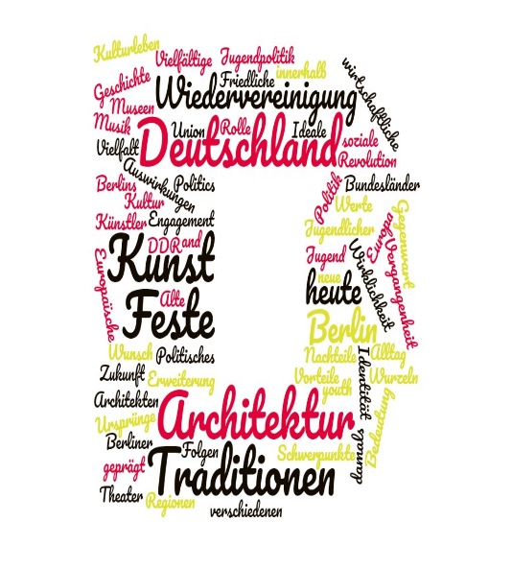
Year 12 Bridging the Gap

Congratulations on your decision to take A Level German.

Did you know that 26% of English words have the same roots as German? German is among the most widely spoken language in the European Union and is the official language in Germany, Austria and Liechtenstein. It's also one of the official languages of Switzerland and Luxembourg. It is also the third most commonly taught language in the world!
It might seem a bit of a jump to A level so putting in some preparation work now will really help you get off to a flying start in September. Below are lots of different websites for you to check out. You do not need to use them all, but here is a variety for you to explore!

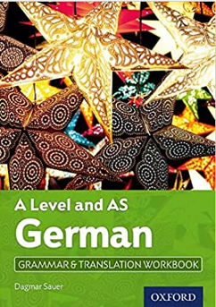
To support your transition to Year 12 and to further your grammar knowledge during the two course we would ask you to please purchase the AS and A-Level German Grammar & Translation Guide (which you otherwise will have to purchase at the beginning of Y12). Please work through the pages 5-11. A Level and AS German Grammar & Translation Workbook: With all you need to know for your 2021 assessments (A Level German): Amazon.co.uk: Sauer, Dagmar: 9780198415510: Books. These exercises will be the basis for our first couple of lessons. Should you find it difficult to source the book please find the exercises attached. Please bring to your first lesson.

Here a few ideas for the summer:

Have a look at the topics for the A Level course below and complete the exercises.

A Level German
Subject Knowledge: Themes and Sub-Themes
Familiarise yourself with the topics you are going to study next year. Translate the themes and sub-themes into English.
Theme 1: Gesellschaftliche Entwicklung in Deutschland
Social Development in Germany
German |  | English Translation
Natur und Umwelt
Umweltbewusstsein
Recycling
Erneuerbare Energie
Bildung
Bildungswesen und die Situation von Studenten
Sitzenbleiben
Berufsausbildung
Die Welt der Arbeit
Das Arbeitsleben in Deutschland und die Arbeitsmoral
Deutsche Geschäfte und Industrien
Theme 2: Politische und künstlerische Kultur im deutschen Sprachraum Political and artistic culture in the German-speaking world
German | English Translation
Musik – (künstlerische Kultur)
Wandel und Trends
Einfluss der Musik auf die populäre Kultur
Die Medien – (politische und künstlerische Kultur)
Fernsehen
Digital-, Print- und Onlinemedien
Einfluss auf Gesellschaft und Politik
Die Rolle von Festen und Traditionen – (künstlerische Kultur)
Feste, Feiern, Sitten, Traditionen
- Write a list of German nouns, verbs, adjectives and phrases connected with the themes in bold above.

- Start to think about and research some of these themes. Can you think of positives/advantages or negatives/disadvantages connected with them?

- Start to form your own opinions about each theme. How would you go about expressing these opinions in German? Compile a list of opinion phrases to express what you think.

Work on your listening skills!
This Photo by Unknown Author is licensed under CC BY
- Slowly spoken news (langsam gesprochene Nachrichten) – this site is updated each day with the current news being read a little slower than normal. It’s great for training your ear, but don’t expect to understand every other word.
- Over time, you will begin to notice a difference in your listening work. It also has an audio script available which is really helpful for learners.
- http://www.dw.com/de/deutsch-lernen/nachrichten/s-8030
- Visit www.deutsch-perfekt.com/ and listen to their weekly podcast, read the news or learn the Wort des Tages.
- Visit www.slowgerman.com/ Listen to their podcasts about Germany.
- Listen to free podcasts on Coffee break German Coffee Break German Archives - Coffee Break Languages

German songs
- Here’s a link to a site which lists 10 classic German songs with details about each one. You can easily find the audio with a quick Internet search. Listening to songs is a great way of picking up new vocabulary as well as helping to improve your pronunciation skills.
- http://www.fluentu.com/german/blog/learn-german-with-songs-music/
- http://www.young-germany.de/topic/work/language-communication/ten-pop-songs-thatwill-help-you-learn-german
- Learn Languages with Music Videos, Lyrics and Karaoke! (lyricstraining.com)

Watch some German!

- Watch a couple of German films on DVD. (There are plenty in the school library.) We study ‘Good Bye Lenin’ in Year 13.
- Watch to the German news. The children’s news is probably more accessible at this stage: www.zdf.de
http://www.tivi.de/fernsehen/logo/start/
- Watch any German TV channel, e.g. ARD, ZDF, RTL, SAT 1 if you have Sky or cable TV or access them through the internet. www.ard.de or www.zdf.de

Visit some useful websites!

- The Goethe Institut website: http://www.goethe.de/ins/gb/lon/prj/asa/enindex.htm here you can find out about current affairs in a format for Sixth Form students. This is also a useful link: A-Level / Advanced Higher German Topics - German for Young People - Goethe-Institut Vereinigtes Königreich
- There is also a website from the Goethe Institute: www.aufdeutsch.co.uk. This is aimed at GCSE students but is quite challenging.
- The Deutsche Welle website offers current affairs articles: www.dw.de . The text is automatically in English, but you can then select German.

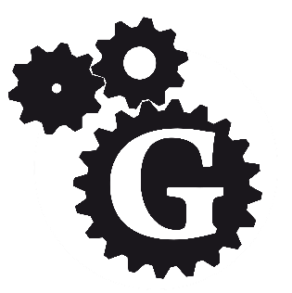
Gaps in your grammar?

In order to support your learning, it is really important that you have a good understanding of German grammar. You may feel confident with the grammar you met in your GCSE course (or you might not!), but you will be meeting some more complex grammar in your A level course. It’s a bit like knowing the rules for a game. You wouldn’t expect to be able to learn the rules easily just by simply watching a sport! You will need to get a grip on grammar!
- For a refresher, try this site. This is aimed at GCSE students but if you feel unsure about the basics, this is a good place to start. http://www.languagesonline.org.uk/Hotpotatoes/germanindex.htm#Grammar
- If you are unsure about your understanding of grammatical terms, this could be the site for you. http://grammarist.com/glossary/
- If you would like a bit of a challenge, here is a link to a great site with more complex grammar exercises.
http://deutschdrang.com/dir/online-exercises/
- Work on www.languagesonline.org.uk/ and http://gut.languageskills.co.uk to consolidate your knowledge of grammar. You should have a clear understanding of the tenses (present, past perfect and pluperfect, future, conditional and modal verbs), cases and word order and could review any GCSE grammar point of which you are uncertain.

- We recommend you use the online dictionaries beolingus.de and leo.de but you should also purchase a good German dictionary as the online dictionaries are not always adequate for checking which case certain verbs take etc. We would advise therefore that you purchase the Concise Oxford Duden German Dictionary before September.

Finally, have a browse of this Padlet. We use Padlet a lot in the 6th form to share reading material and resources for the various topics. This Padlet contains some of the websites mentioned in this document. Deutsch in der Oberstufe (padlet.com)

Most of all enjoy your language learning and if you come across any great podcasts, YouTube channels or anything else please share with us in the first lesson.
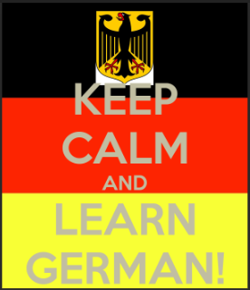
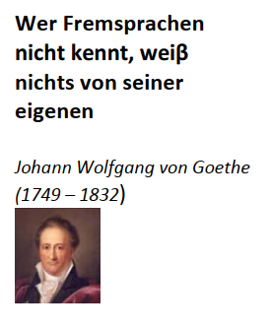

Remember having an A-Level in a language shows that you are a competent linguist and it is a sought after qualification in all spheres of work. You will become aware of the cultures and diversity within Germany and see the important role that Germany continues to play in Europe in politics, business and trade.

Viel Spass und bis September .......wir freuen uns schon darauf!

