Accessing JSTOR on a computer at home.
Students will need to click on the token link:-https://www.jstor.org/token/ftc6JqeViNsn8KqqQG3x/cchs.co.uk the first time they use MyJSTOR to access it from off site. If they already created a MyJSTOR account, they can simply login once they click the token and the token will then be attached to their account.

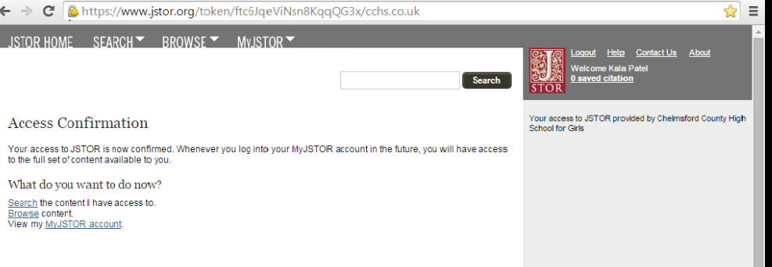

If they have not yet created a MyJSTOR account, clicking on "Register" after following the token link will allow them to create an account that is functional off site.
