AQA

A Level PE

Bridging Work

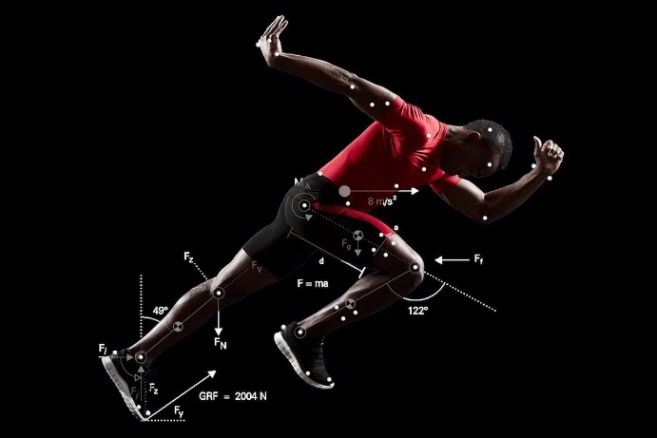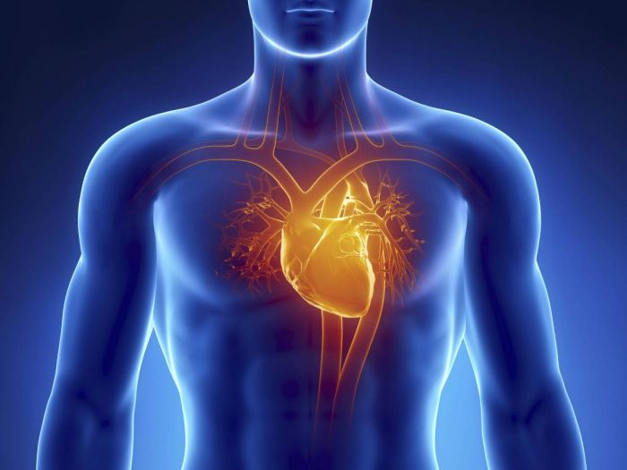

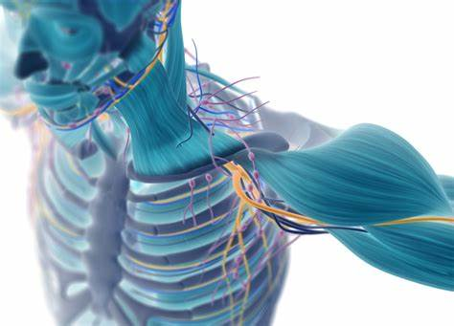

Name:_________________________

Applied Anatomy &

Physiology

____________ ____________ 🡪 the volume of blood pumped out by the heart ventricles in each contraction.

_____________ ____________ 🡪 the volume of blood pumped out by the heart ventricles per minute.

= HR x SV

Cardiovascular SYSTEM

Label the heart – some of

these areas might be new!

**Starling’s Law** – stroke volume increases in response to an increase in ____________

_____________ .

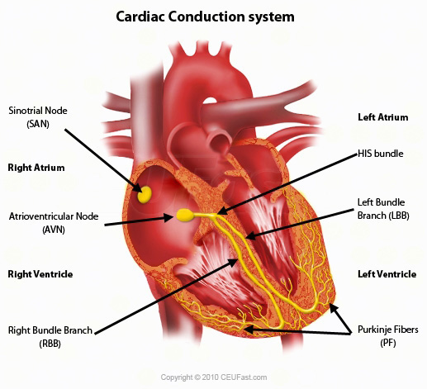

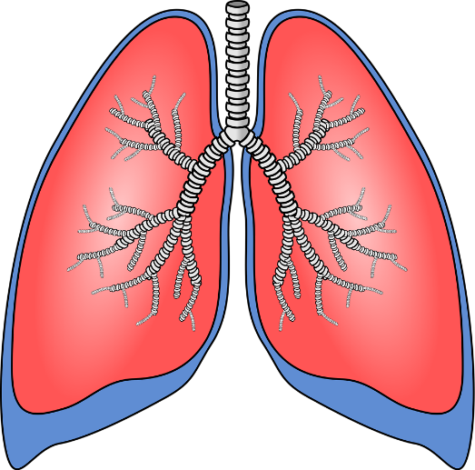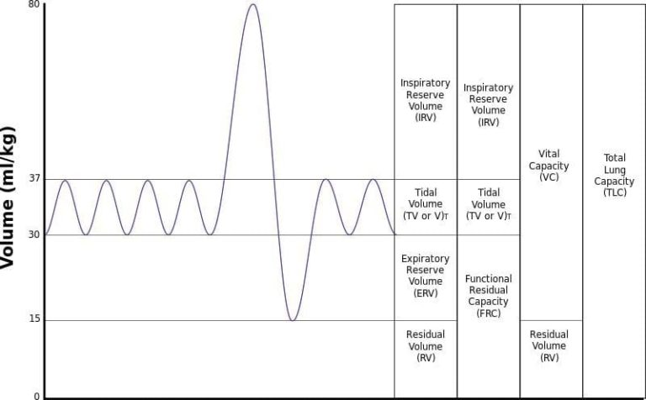

**Lungs** are the main organ involved

in respiration.

Label the Spirometary

Graph

The **diaphragm** changes shape during ventilation:

___________ - contracts and flattens.

___________ - relaxes and becomes dome shape.

RESPIRATORY SYSTEM

Name the 4 muscles involved with respiration:

* __________________
* __________________
* __________________
* __________________

**Sympathetic Nervous System** – prepares the body for exercise/increases the heart rate.

**Parasympathetic Nervous System** – slows the body down/decreases the heart rate.

NEUROMUSCULAR SYSTEM

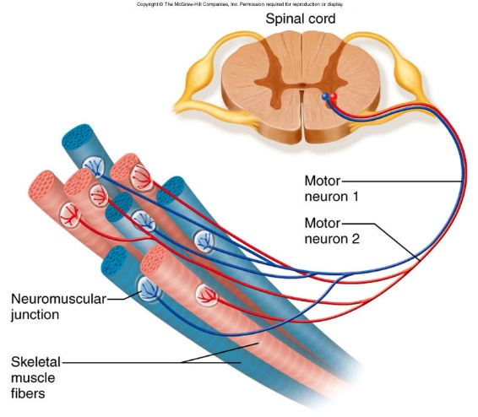

Motor Unit

Research Task:

Proprioceptive Neuromuscular Facilitation (PNF)

Research PNF and find out as much information as you can.

What type of muscle contraction takes place? What are muscle spindles and golgi tendon organs?

Biomechanics

Newton’s Laws of Motion:

1. Newton’s First law =
2. Newton’s Second law =
3. Newton’s Third law =

BIOMECHANICAL

PRINCIPLES

**1 – 2 – 3**

**F – L – E**

In the box below, draw and label all 3 lever systems.

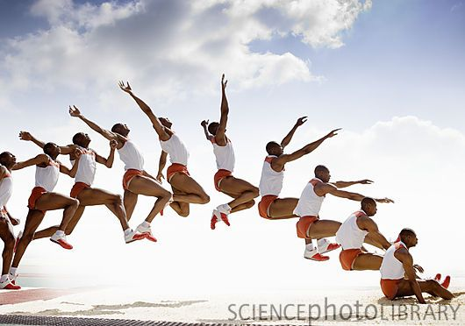

PROJECTILE

MOTION

Projectile motion refers to movement of either an object or the human body as they travel through the air. In sport, as soon as a ball is released in a kick, hit or throw it becomes projectile. The human body acts as a projectile in a variety of sports too.

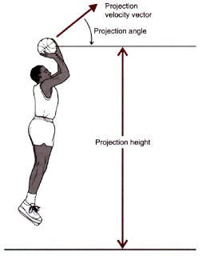

Write down as many sports as you can where an object or a body becomes a projectile.

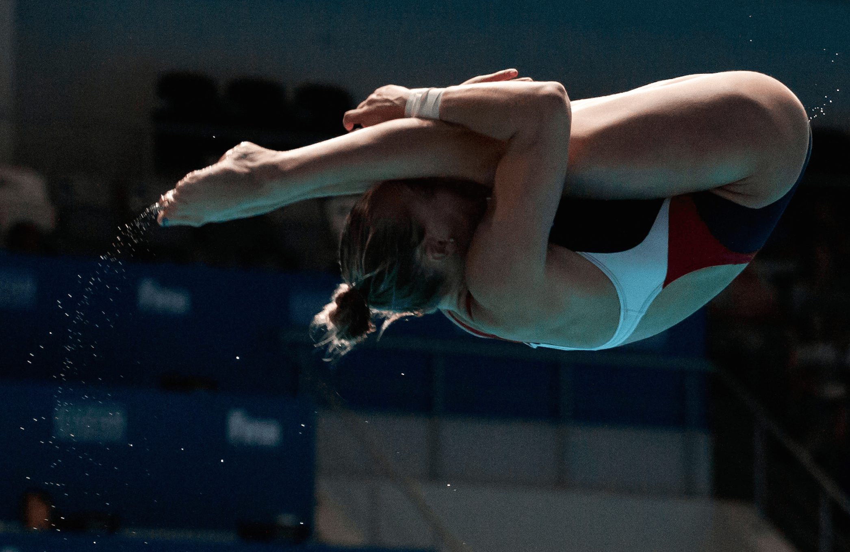

ANGULAR

MOTION

Angular motion occurs in sport all the time. It refers to rotation and involves movement around a fixed point or axis. It can involve the whole body in a somersault or a body part such as the arms.

What sports involve angular motion? Write down some examples.

Skill Acquisition

Write down 12 different skills from various different sports and add each skill to each continuum.

Be specific: e.g. a tumble turn in swimming, a shot in netball, a serve in tennis.

CLOSED

OPEN

FINE

GROSS

COMPLEX

SIMPLE

SKILL CLASSIFICATION

SELF-PACED

LOW

ORGANISATION

EXTERNALLY

PACED

HIGH

ORGANISATION

Research Task:

Methods of presenting practice

Skills can be presented as a whole or by breaking them down into sub-routines. The decision oh which type of practice to use depends on the type of skill.

Research different types of practice performers might use when training.

*Verbal Guidance* – an explanation of the task. It is nearly always used in conjunction with visual guidance, when a coach speaks to a performer during the demonstration.

*Visual Guidance* – a demonstration of the required task. The intention is to create a mental image for a beginner that can be used as a reference for future practice.

METHODS OF GUIDANCE

*Mechanical Guidance* – involves using a device to help performance.

*Manual Guidance* – involves physical support from a coach or peer.

For each method of guidance, give at least 2 sporting examples of when this might occur, and list 2 advantages and disadvantages for each.

Observational Learning – Bandura

Research this theory that was researched by Bandura in 1977.

What does this theory suggest?

What is the model for this particular learning theory?

Research Task:

SPORT & SOCIETY

Real Tennis

PRE-INDUSTRIAL BRITAIN: POPULAR RECREATION

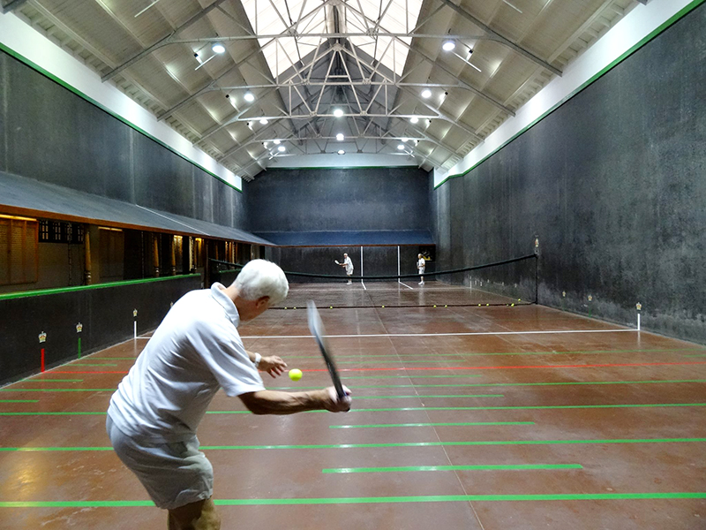

Mob Football

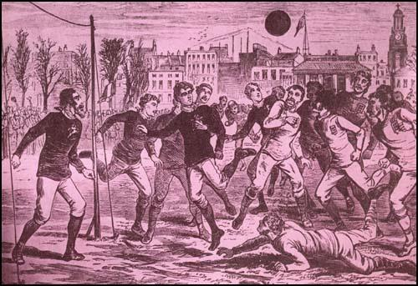

Research Task:

KEY TERMS

**Popular recreation** – the sport and pastimes of people in pre-industrial Britain.

**Feudal system** – broadly defined, it was a way of structuring society around a relationship derived from the holding of land in exchange for service or labour.

Do you know anything about these popular recreational activities from pre-industrial Britain?

Research each activity and see what interesting facts you can find!

Who played these activities and when?

What equipment/venue was used?