**ART – ‘Boundaries’**

To help you with a successful transition from GCSE to A level it is important to make sure that your observational drawing skills are up to a high standard. Completing the following tasks will help you to improve your drawing standards to the best of your ability at the present time.

Advanced Art homework’s should take you about **3-4 hours per week**, which may feel like a lot, however, remember that you are doing fewer subjects.

**To help you prepare for September we ask that you complete an observational drawing of a tap and towel showing two contrasting textures.**

This A4 pencil drawing should show the difference in surface texture

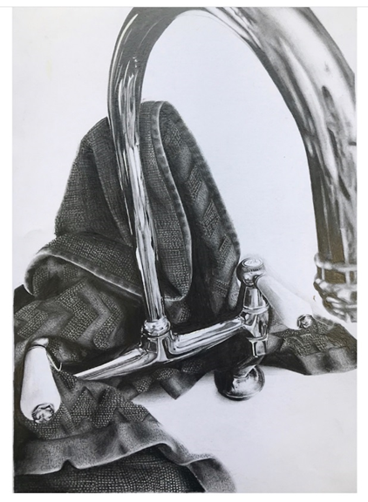Example below:

It is important to remember that commitment to the subject will help you attain the highest grade possible, and we therefore request that you spend a suitable amount of time prior on this work over the summer period.

When you return to school in September, we request that you bring the piece of work with you, and they will be marked to the appropriate criteria. Where possible, the studies will be part of your coursework and go towards your final grade. Where this has not been possible, please speak to your Art teacher when you arrive in school.

In addition to the set piece, if possible, we would like you to **visit an Art Gallery or exhibition** and working in a sketchbook, complete two sketches of the pieces you like most. Then add some notes about your chosen pieces and the whole exhibition, explaining your own personal thoughts and feelings. You should include any pamphlets or postcards that you are able to acquire.

Your teachers this year will be Mr Harvey and Miss Stevens. We try hard to make the course as varied and interesting as possible.

Finally, we hope you enjoy your two years!

Mr Harvey

(Head of the Creative Faculty / Head of Art)

jharvey@cchs.co.uk