**Name: Teacher(s);**

Research Methods

AQA A Level

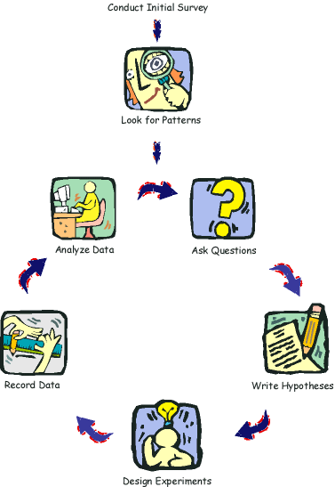Activity Booklet

**Topics include:**

* **Section A Methods and Techniques**
* **Section B Investigation Design**
* **Section C Data Analysis and Presentation**

The aim of this booklet is to provide you with a structure for your notes and practical activities to enhance your understanding of research methods within psychology. These notes underpin your understanding of psychology and will need to be applied throughout the course, so take care of this booklet and make use of it.

**The Specification**

|  |  |  |  |  |
| --- | --- | --- | --- | --- |
| **Methods & techniques**  **A** | Candidates will be expected to demonstrate knowledge & understanding of the following, including strengths & limitations:   * Experimental method, including laboratory, field, natural & quasi experiments. * Observational techniques; naturalistic, controlled, covert, overt, participant & non-participant. * Self-report techniques; questionnaires & interviews (structured & unstructured). * Correlations. Difference between correlations & experiments. | **Covered** | **Revised** | **☺ :/ ☹** |
| **Scientific processes**  **B** | * Aims. * Hypotheses: directional and non-directional. * Difference between population & sample: sampling techniques; random, systematic, stratified, opportunity & volunteer. Implications: bias & generalisation. * Pilot studies & the aim of piloting * Experimental design: independent groups, repeated measures and matched pairs. * Observational design: behavioural categories, event sampling & time sampling. * Design of questionnaires (open & closed questions) & interviews. * Operationalisation of variables, including independent, dependent, extraneous & confounding variables. * Control: random allocation, counterbalancing, randomisation & standardisation. * Demand characteristics & investigator effects. * Ethics: British Psychological Society (BPS) Code of Ethics, issues in design & conduct of research. * Role of peer review. * Implications of psychological research for the economy. |  |  |  |
| **Data handling & analysis**  **C** | * Quantitative & qualitative data collection techniques. * Primary & secondary data: including meta-analysis. * Descriptive statistics: measures of central tendency (median, mean, mode), measures of dispersion (range & standard deviation), calculation of percentages, positive, negative & zero correlations. * Presentation & display of quantitative data: graphs, bar charts, scattergrams and tables. * Distributions: normal & skewed distributions. * Introduction to statistical tests: the sign test. |  |  |  |

[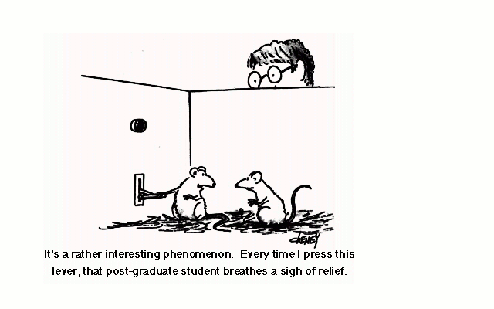](http://www.google.co.uk/url?sa=i&rct=j&q=&esrc=s&frm=1&source=images&cd=&cad=rja&uact=8&docid=a1lOPgA_P34bJM&tbnid=S5-FZvv3iYC9jM:&ved=0CAUQjRw&url=http://radiofreethinker.com/tag/vancouver/&ei=kxeYU-_0J-2S0AWavoHADw&bvm=bv.68693194,d.ZWU&psig=AFQjCNEEk9SfcI7DDhxk6rix0g5VbtlPCw&ust=1402562805930155)[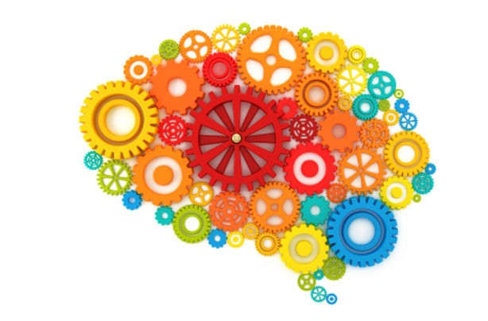](http://www.google.co.uk/url?sa=i&rct=j&q=&esrc=s&frm=1&source=images&cd=&cad=rja&uact=8&docid=lcpPso88pk7yCM&tbnid=Ii78uj138YQTZM:&ved=0CAUQjRw&url=http://www.goodtoknow.co.uk/money/galleries/34399/50-ways-to-make-extra-money/19&ei=3RSYU4_5JojV0QWNyoDwDA&bvm=bv.68693194,d.ZWU&psig=AFQjCNGJnmX1HUUkEQ4U_WdeA-JgBphKxg&ust=1402562085462160)**Methods and Techniques used in Psychological Research**

[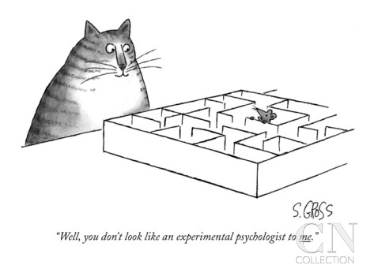](http://www.google.co.uk/url?sa=i&rct=j&q=&esrc=s&frm=1&source=images&cd=&cad=rja&uact=8&docid=-uPWNMb0FU7-bM&tbnid=G9Fuys77ot0YPM:&ved=0CAUQjRw&url=http://www.condenaststore.com/-sp/Well-you-don-t-look-like-an-experimental-psychologist-to-me-New-Yorker-Cartoon-Prints_i8541421_.htm&ei=ER2gU_PhF8-h7AaP5IHICQ&bvm=bv.68911936,d.ZGU&psig=AFQjCNEKRJpmt4oijfyU_062zy4LSgiOHA&ust=1403088404757556)

***[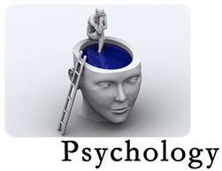](http://www.google.co.uk/url?sa=i&rct=j&q=&esrc=s&frm=1&source=images&cd=&cad=rja&uact=8&docid=wOAh_R0FDfPw6M&tbnid=Ppnu0IJsQssR7M:&ved=0CAUQjRw&url=http://lamaghanem.blogspot.com/&ei=qhSYU8idGYib0QXy8IGoAw&bvm=bv.68693194,d.ZWU&psig=AFQjCNGJnmX1HUUkEQ4U_WdeA-JgBphKxg&ust=1402562085462160)***

My section A test mark is:

***Section A***

**Methods and Techniques**

**Experimental Methods**

To be an experiment there must be an i………………………………….. variable which is **changed** by the experimenter and a d …………………………………… variable which is **measured**. **Task; Fill in the table below:**

|  |  |  |  |
| --- | --- | --- | --- |
| **Research Method** | **Definition:** | **Advantages** | **Disadvantages** |
| **Laboratory experiment** | **The IV is ………………………………**  **And the DV is …………………………**  **In a controlled environment.** | **+ve High degree of control because……** | **-ve Demand characteristics which are ……** |
| **Field experiment** |  |  |  |
| **Natural experiment** | These are often considered to be the same.  IV **varies** naturally, situations not manipulated by the experimenter. E.g |  |  |
| **Quasi experiment** | IV **occurs** naturally, not manipulated by the experimenter, often participant variables. E.g. gender of participants. |  |  |

**TASK: Identify which experimental method is being used for each example.**

1. A researcher wanted to find out the effects of caffeine on memory. The researcher had two groups of participants in a room. One group drank strong coffee and were then given a list of words to recall. The second group were given a warm, caffeine free drink and were given a list of words to recall.

**Answer: _____________________________________**

1. Researchers were interested in how watching T.V affects aggression in children. They measured the levels of aggression shown by the children in the school playground before T.V. was introduced by the local government and afterwards.

**Answer: _____________________________________**

1. Researcher looked at gender differences in non-verbal communication. They counted the number of smiles received from men or women while serving them in a shop.

**Answer: _____________________________________**

1. Researchers were interested in whether cats prefer playing with mice shaped toys or bird shaped toys. Each group of cats was given one type of toy to play with in their own home and the time they played with it for was recorded.

**Answer: _____________________________________**

1. Researchers looked at whether people with OCD would be better or worse at completing a memory task. They interviewed 10 adults with OCD and 10 adults who did not have OCD.

**Answer: _____________________________________**

1. A researcher wanted to see if people would help someone on the tube. They set up a situation where a confederate would collapse during a tube journey. The confederate appeared drunk in one condition and sick in the other condition. The researchers observed the behaviours of the passengers witnessing the event.

**Answer: _____________________________________**

**[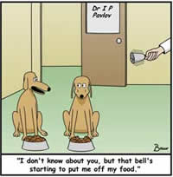](http://www.google.co.uk/url?sa=i&rct=j&q=&esrc=s&frm=1&source=images&cd=&cad=rja&uact=8&docid=KFG_EWFFyW0-aM&tbnid=Mds7DHWLnsDgnM:&ved=0CAUQjRw&url=http://jmccrackenworld.com/PSYCHDECWK2.html&ei=0B-XU8LxJczpoATnlIHACQ&bvm=bv.68445247,d.d2k&psig=AFQjCNHqhlX8BowKRcFMga0iPZDtv8j9qg&ust=1402499387564740)Examples of psychology experiments.**

**Task; Make brief notes on each of the named studies below and decide which type of experiment it is (laboratory, field, natural). Then explain why you think this.**

HINT; How to find psychological research. Search for the names (these are the researchers) & specific date given (when the research was published) as many psychologists have carried out several pieces of research and it important to be reading about the correct study.

**Yuille and Cutshall (1986).** Brief description

Type of experiment:

Why do you think that? (Justify your answer)

**Loftus and Palmer 1974.** Brief description

Type of experiment:

Why do you think that? (Justify your answer)

**Hofling et al 1966** Brief description

Type of experiment:

Why do you think that? (Justify your answer)

**Observational techniques**

A researcher might decide to conduct an observation instead of an experiment. There are different types of observational method to choose from. **Be careful not to confuse a naturalistic observation with a natural experiment - the two are different!**

NB: P’s refers to participants.

**Task: Match up the following terms:**

1. Situation is natural, researcher does not interfere.
2. The person recording the activity is not part of the activity.
3. Observing P’s without their knowledge.
4. Situation is artificial and set up by researcher.
5. Observing P’s with their knowledge.
6. The person recording the activity is also taking part in it.
7. Controlled observation
8. Naturalistic observation
9. Participant ob.
10. Non- participant ob.
11. Overt ob.
12. Covert ob.

**For each type of observation describe an example (you can research real studies or make up your own examples, just ensure it is clear why they fit this type of observation).**

* Controlled observation

e.g.

* Naturalistic observation

e.g.

* Participant observation

e.g.

* Non-participant observation

e.g.

* Overt observation

e.g.

* Covert observation

e.g.

**Task:** Complete the table below for observations. Some points may be relevant for certain types of observations only so make this clear in your points. See example below.

|  |  |
| --- | --- |
| **Advantages** | **Disadvantages** |
| +ve Few demand characteristics with a covert observation as P’s are unaware they are being observed so are unlikely to change their behaviour. |  |

**Self-Report Techniques**

**Interviews and Questionnaires**

One of the best ways to elicit information from people is to ask them. Psychological research likes to make use of questionnaires and interviews as an efficient way of gathering a large amount of data.

<https://www.youtube.com/watch?v=9t-_hYjAKww>

**Task; Here are a few investigation aims. For each one suggest 3 questions you might ask in a questionnaire or interview.**

1. Students views on school uniform.
2. Vegetarian’s thoughts on a new restaurant.
3. A pop star’s view on being famous.

**Suggest when a questionnaire would be more suitable than an interview.**

**Questionnaire**

**Questionnaire**

**Interview**

Closed questions are…….

Open questions are…………..

What is it?

e.g…………………………………………………………………………………………..

|  |  |
| --- | --- |
| **Advantages** | **Disadvantages** |
|  |  |

Structured interviews are…….

Unstructured interviews are…………..

**Interview**

What is it?

e.g………………………………………………………………………………

|  |  |
| --- | --- |
| **Advantages** | **Disadvantages** |
|  |  |

**Design Issues**

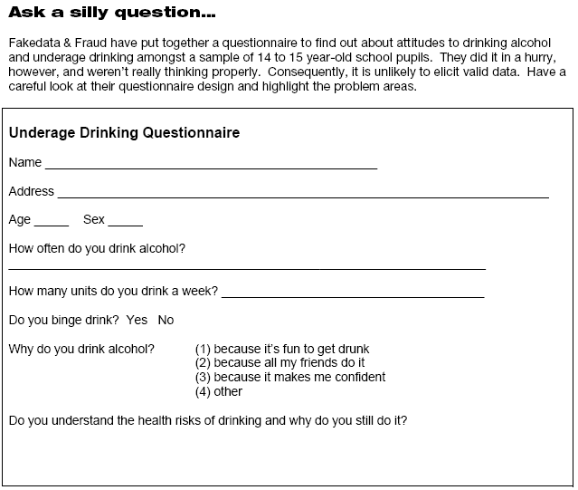**Task: Sometimes questionnaire designs can go drastically wrong. Look at the questionnaire below and identify the main errors and how to control them (improvements).**

|  |  |  |
| --- | --- | --- |
| Main Flaws: | Problems they cause: | How to control them: |
|  |  |  |

**Correlational research** (both a research method & a way of analysing data)

Sometimes researchers want to look at patterns between variables which they believe may be connected. Comparing the relationship of one variable to another (co-variables) is a correlation. These are different to experiments as there is no independent variable manipulated and no dependent variable measured.

e.g. Does playing violent computer games make teenagers more aggressive?

**Task:** Suggest 3 more examples.

|  |  |
| --- | --- |
| **Advantages** | **Disadvantages** |
|  |  |

**Task:** Design a correlational study that studies the relationship between age of adoption and life success. What would your co-variables be and how would you measure them?

Other research methods used in Psychology

**TASK:** Match up the research methods and correct definitions below.

|  |  |  |  |
| --- | --- | --- | --- |
| *Research Method* |  | *Definition* | *Examples (from those listed below).* |
| **Case studies** | Turns qualitative data into quantitative. Enables direct study of behaviour by examining communications. Coding can be used to identify what is being looked for. |  |
| **Meta analysis** | Keeps qualitative data qualitative. Identifies implicit or explicit ideas and themes within different forms of communication. |  |
| **Content analysis** | An in-depth investigation, description and analysis of a single individual, group, institution or event. |  |
| **Thematic analysis** | Comparing a range of results from different studies on the same topic. Drawing conclusions from the studies as a whole. | Malik & Coulson (2008) |

**TASK:** Examples to add to table.

Little Hans (1908)

Van Ijzendoorn & Kroonenberg (1988)

Little Albert (1920)

Furnham & Farragher (2000)

**[](http://www.google.co.uk/url?sa=i&rct=j&q=&esrc=s&frm=1&source=images&cd=&cad=rja&uact=8&docid=3Brh-1s38eqWPM&tbnid=KxVlxTS0bEMXJM:&ved=0CAUQjRw&url=http://www.addictedtosaving.com/daily-recap-thursday-5114/&ei=tKKQU8PfO8TX7AayrYGYCg&bvm=bv.68235269,d.ZGU&psig=AFQjCNGnLXU00QEvCaSbHl3xiaqao2e6hw&ust=1402074081169713)Now take some time to read back over your notes. Make a list here of any questions you have for your teacher/peers to help you with.**

Self-evaluation – how do you feel about this section?

|  |  |  |
| --- | --- | --- |
| **Areas I understand fully** | **Areas I don’t understand fully** | **What I will do about it** |
|  |  |  |

**[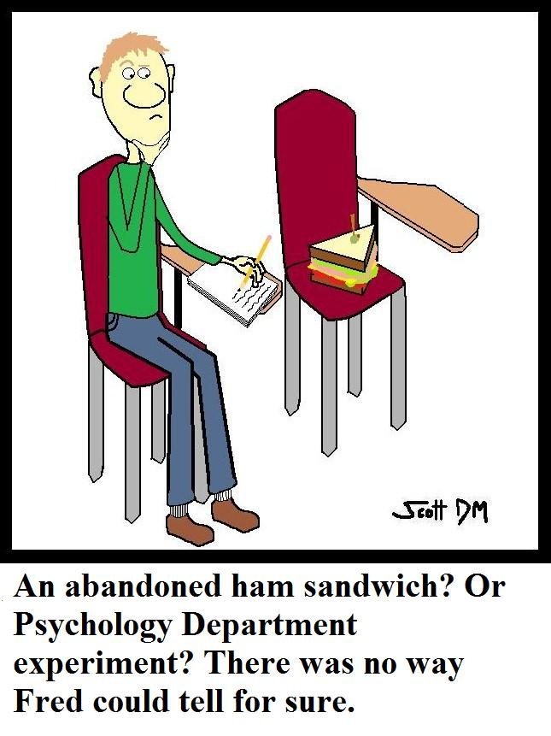](http://www.google.co.uk/url?sa=i&rct=j&q=&esrc=s&frm=1&source=images&cd=&cad=rja&uact=8&docid=sL1cOxKuI7HcmM&tbnid=Z0v8-e6OmmruVM:&ved=0CAUQjRw&url=http://www.macleans.ca/education/uniandcollege/the-ethics-of-psychology-experiments/&ei=T6qQU_LtDKia7Qa804CwAw&bvm=bv.68235269,d.ZGU&psig=AFQjCNHo9NFIvlUGaYktpmuqeyLi0wiw8w&ust=1402076005435593)Investigation Design**

**[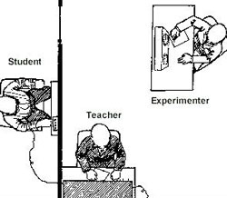](http://www.google.co.uk/url?sa=i&rct=j&q=&esrc=s&frm=1&source=images&cd=&cad=rja&uact=8&docid=9Htj7mWXy_E48M&tbnid=4tFnxJayjCOehM:&ved=0CAUQjRw&url=http://www.betterlucktomorrow.com/character_sites/steve/Psychology%20Experiments.htm&ei=7qmQU76RH_DH7AbzsYCwCg&bvm=bv.68235269,d.ZGU&psig=AFQjCNHo9NFIvlUGaYktpmuqeyLi0wiw8w&ust=1402076005435593)**

**[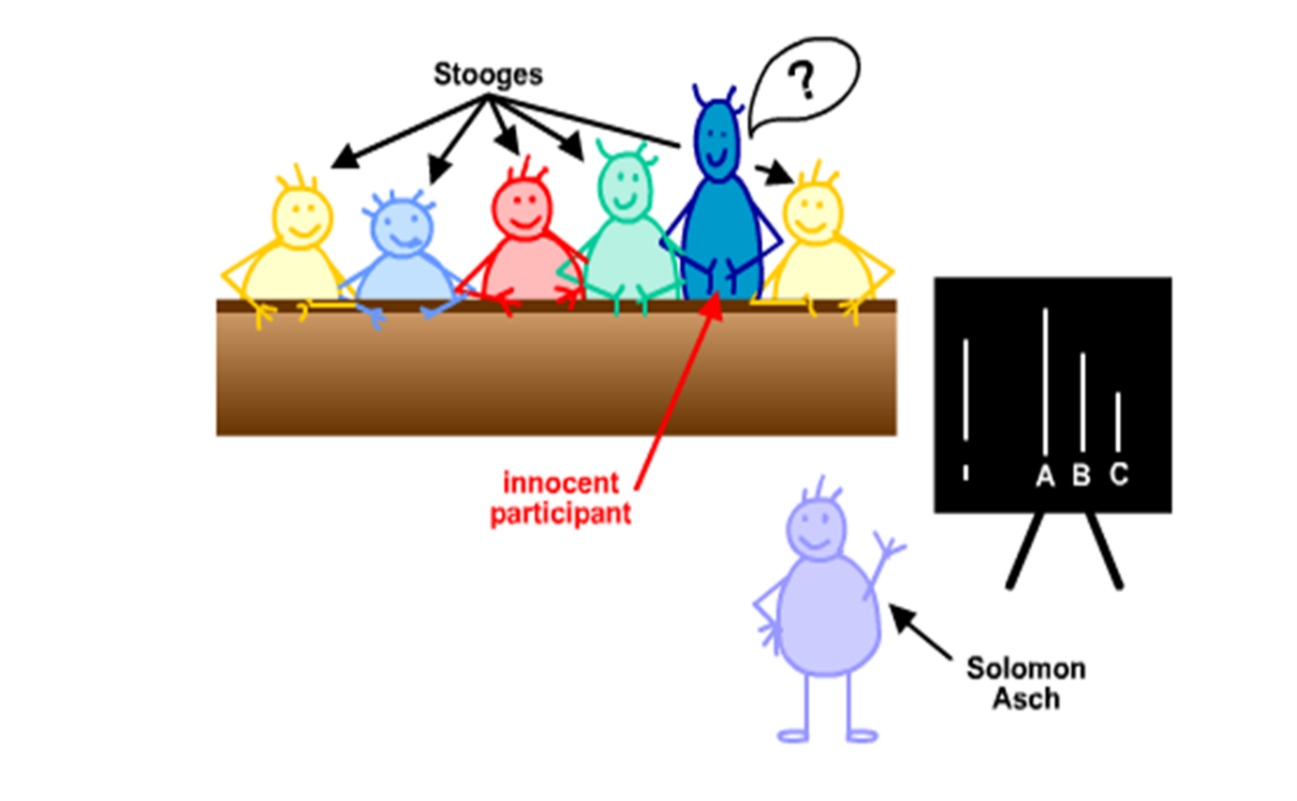](https://www.google.co.uk/url?sa=i&rct=j&q=&esrc=s&frm=1&source=images&cd=&cad=rja&uact=8&docid=R99h-Vnld0cJhM&tbnid=3hsW9NCUZJ195M:&ved=0CAUQjRw&url=https://sites.google.com/site/thepsychofsocialpsychology/classical-studies/conformity&ei=g6qQU__yK4X17Ab44YDgAw&bvm=bv.68235269,d.ZGU&psig=AFQjCNHo9NFIvlUGaYktpmuqeyLi0wiw8w&ust=1402076005435593)**

***Section B***

My section B test mark is;

**Investigation Design**

**Aims and Hypotheses: Fill in the table with correct definitions.**

|  |  |
| --- | --- |
| **Aim** |  |
| **Experimental hypothesis**  **Alternative hypothesis**  **Directional hypothesis**  [http://www.clker.com/cliparts/b/E/V/1/z/3/cartoon-fish-md.png](http://www.google.co.uk/url?sa=i&rct=j&q=&esrc=s&frm=1&source=images&cd=&cad=rja&uact=8&docid=L4lLjUOTEN42SM&tbnid=lAjirKBrFmjBpM:&ved=0CAUQjRw&url=http://www.clker.com/clipart-cartoon-fish-4.html&ei=kteWU9vFBrGf7Abr5ICoBg&bvm=bv.68445247,d.ZGU&psig=AFQjCNECKW4KJMAIP1-kqkBuLZiy-v9axg&ust=1402480837456327)  One-tailed hypothofish can tell which way it is going.  [http://www.clker.com/cliparts/b/E/V/1/z/3/cartoon-fish-md.pnghttp://www.clker.com/cliparts/b/E/V/1/z/3/cartoon-fish-md.png](http://www.google.co.uk/url?sa=i&rct=j&q=&esrc=s&frm=1&source=images&cd=&cad=rja&uact=8&docid=L4lLjUOTEN42SM&tbnid=lAjirKBrFmjBpM:&ved=0CAUQjRw&url=http://www.clker.com/clipart-cartoon-fish-4.html&ei=kteWU9vFBrGf7Abr5ICoBg&bvm=bv.68445247,d.ZGU&psig=AFQjCNECKW4KJMAIP1-kqkBuLZiy-v9axg&ust=1402480837456327)**Non-directional hypothesis**  Two-tailed hypothofish cannot tell which way it is going.  **Null Hypothesis** |  |

**Aims are normally very straight forward, what the researcher is looking for. Task; What might the aim be for the following?**

1. Should students listen to music while revising?
2. Do students who revise perform better?
3. Are cats the best ever pets to own?

An aim of a study should include both the thing being manipulated (independent variable) and the thing being measured (dependent variable).

**Task; Circle the IV’s and underline the DV’s in your examples above.**

Hypotheses must be a clear testable statement and are generally more specific than an aim as the variables must be **operationalised. (More about this on page 24)**

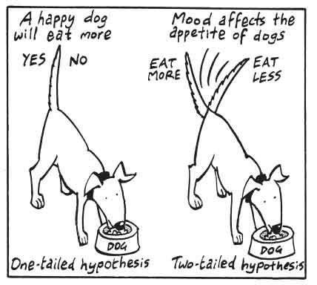RECAP: A **two-tailed hypothesis** means the same as **non-directional** and is unclear about the direction the results will go in (i.e. predicts a change, but not what type or direction of change). They tend to use the words “**there will be a significant difference**…”

**Task: Pick one of the aims from the last task and write your own directional and non-directional hypotheses below:**

Directional:

Non-Directional:

**WHY** dopsychologists use directional or non-directional hypotheses?

Psychologists us a **directional hypothesis** when **past research** (theory or study) suggests that the findings will go in a particular direction.

Psychologists use a **non-directional hypothesis** when past research is unclear or contradictory.

**Task: Identify whether each of the following is a directional or non-directional hypothesis.**

* People who are given an organized list of words, will recall a greater number of words than people given a random list.

………………………………………………………………………………………………………………………………………………………………

* Coffee affects learning

………………………………………………………………………………………………………………………………………………………………

* Cats make better pets

………………………………………………………………………………………………………………………………………………………………

* People who use imagery will recall a greater number of words than those who use rehearsal.

……………………………………………………………………………………………………………………………………………………………

**Task; Now re-write each hypothesis – if it was directional/one tailed re-write it as a non-directional/two-tailed hypothesis, but if it was non-directional/two-tailed, re-write it as a directional/one tailed hypothesis.**

* People given a word list in which categories can be found, will recall a greater number of words than people given a random word list.

………………………………………………………………………………………………………………………………………………………………………………………………………………………………………………………………………………………………………………………………………………………………………………………………………………………………………………………………………………………………

* Coffee affects learning

………………………………………………………………………………………………………………………………………………………………………………………………………………………………………………………………………………………………………………………………

* Cats make better pets

……………………………………………………………………………………………………………………………………………………………………………………………………………………………………………………………………………………………………………………………

* People who use imagery will recall a greater number of words than those who use rehearsal.

………………………………………………………………………………………………………………………………………………………………………………………………………………………………………………………………………………………………………………………………………………………………………………………………………………………………………………………………………………………………

**Who are you researching?**

**Task: Complete definitions for the terms below.**

Target population:

Sample:

Generalisable:

Unrepresentative:

Ideally you should be able to generalise from your sample to your target population, but this is not always possible if the sample is unrepresentative.

**Sampling Techniques**

So you’ve worked out who your sample needs to be, how are you going to obtain participants?

**TASK: Describe each type of sampling and suggest an advantage and a disadvantage.**

**Opportunity Sampling:**

**Volunteer Sampling:**

**Stratified Sampling:**

**Systematic Sampling:**

**Random Sampling:**

*Q: Researchers rarely use random sampling. Suggest why?*

**Improving Validity - Pilot Studies:**

Designing a pilot study is usually the best way to check that everything in your actual experiment will run smoothly.

**Task: fill in the gaps.**

A pilot study is a sm__________ scale study conducted on a small sample. It helps the researcher to identify any pa___________ problems with the re___________ method, design, in_____________ given to participants and so on. Pilot studies can also check items on a qu or in to make sure that they are easy to answer and unambiguous.

**Q: You have been asked to carry out an experiment into the effects of music on the ability to recall words from a list. What might go wrong?**

**Q: Which elements of the experiment would you test in the pilot study** *(e.g. duration/volume of music playing)?*

**Experimental Design:**

Once the researcher has chosen the experimental method which best suits the nature of the study, they then have to choose what type of design it will have. The choices are **repeated measures, independent groups** and **matched** **pairs**.

**Task: Draw out stick people or cut and stick paper people in each box to show: repeated measures independent groups matched pairs**

|  |  |  |
| --- | --- | --- |
|  |  |  |

**Task: Now fill in the table below.**

|  |  |  |
| --- | --- | --- |
| **Design** | **Strengths** | **Weaknesses** |
| **Repeated measures**  The same P’s are used in both conditions. |  |  |
| **Independent Groups**  P’s are randomly allocated to different groups which represent the different conditions. |  |  |
| **Matched Pairs**  Pairs of P’s are closely matched and are then randomly allocated to one of the experimental conditions. |  |  |

**TASK: Which design is being used in each of the following examples?**

1. Researchers wanted to find out whether a new teaching method could improve verbal reasoning ability in 5 year olds. In one condition the children were taught the new method and in the other they were taught a traditional method. Each participant in the new method group was matched with a participant from the other condition.
2. Researchers were looking at whether people remembered more in the morning or evening. They gave one set of participants free recall tests in both the morning and evening and compared their results to the control group who only took the test in the morning.
3. A researcher enrolled 20 participants into their experiment. All participants completed a musical task and then a written task. Their abilities to perform under pressure were compared.

**Observational design**

**Task: Recap: Observations can be divided into sub-categories;**

* P____________ based – observer interacts with the participants.
* N____- P______________ based – observer does not interact with participants
* Covert –
* Overt -

**Q; Recap: How are a naturalistic observation and a natural experiment different?**

**Task: Recap: Which type of observation is being described below?**

The researcher sits in an airport waiting area and observes the stressed behaviour of people waiting to fly.

**Answer:** _____________________

The researcher joins a football team to observe the possible racist behaviour of the players.

**Answer:** _____________________

Children playing with certain toys are watched through a one-way mirror.

**Answer:** _____________________

Shoppers in a supermarket are observed choosing branded foods by a researcher with a clipboard wandering around the store.

**Answer:** _____________________

**Q: Is there some overlap between observations types? Explain your answer.**

**Behavioural Categories**

A behavioural category is a specific type of behaviour which is defined before the study takes place. It allows researchers to focus their investigation on a specific behaviour (or several) in order to gather the most valid and reliable data.

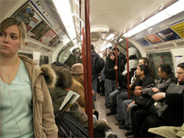**If observing helping behaviour on the tube, suggest some categories you might look out for.**

|  |  |  |  |  |
| --- | --- | --- | --- | --- |
| Category: |  |  |  |  |

You would then tally up how many of each behaviour category you had seen. Inter-rater reliability could be checked by having two observers who then compared data from the same observation. To make observations even more specific you can use **event sampling**:

or **time sampling:**

**Design of questionnaires/interviews**

**TASK:** Imagine you are going to interview a person about problems with their short term memory. Write 3 open and 3 closed questions which you will ask.

How could you go about ensuring this is a structured interview?

How could you go about ensuring this is an unstructured interview?

**Operationalising Variables**

**Task: Definition of operationalisation:**

It is very important to operationalise the variables to be studied, otherwise the researcher will not know what they are looking for and this can reduce the validity and reliability of their data. The same area of research could be operationalised in many different ways.

[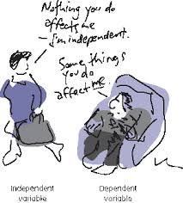](http://www.google.co.uk/url?sa=i&rct=j&q=&esrc=s&frm=1&source=images&cd=&cad=rja&uact=8&docid=HPu6l2jNRZWKNM&tbnid=h5-Kfyp61oDwGM:&ved=0CAUQjRw&url=http://jesserabinovitch.weebly.com/research--program-evaluation.html&ei=hhWYU-PTBK6W0QXXmoAI&bvm=bv.68693194,d.ZWU&psig=AFQjCNGJnmX1HUUkEQ4U_WdeA-JgBphKxg&ust=1402562085462160)**For example** if a researcher wanted to measure whether cats make the best pets they could operationalize the independent variable (IV) = cats or dogs. The dependent variable (DV) score out of 100 on a questionnaire.

OR

IV = Cats or fish.

DV = how much their owners pay in vets bills.

Independent variable Dependent variable

(changed) (measured)

[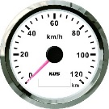](http://www.google.co.uk/url?sa=i&rct=j&q=&esrc=s&frm=1&source=images&cd=&cad=rja&uact=8&docid=PX5625Y_01EDyM&tbnid=OwJIXgY6WygvTM:&ved=0CAUQjRw&url=http://www.aliexpress.com/popular/gps-speedometer-motorcycle.html&ei=MSCYU4PwFKSe0wX03oG4Aw&bvm=bv.68693194,d.ZGU&psig=AFQjCNGnFed_3qtGRjItbolhN8ZkwmLLGw&ust=1402565034923082)**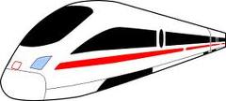Task: How might the following variables be operationalised, suggest two ways for each?**

* Speed

[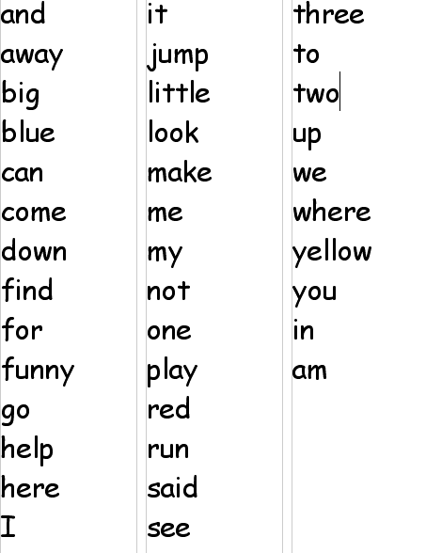](http://www.google.co.uk/url?sa=i&rct=j&q=&esrc=s&frm=1&source=images&cd=&cad=rja&uact=8&docid=zwMCOIox8R23FM&tbnid=V1ErWsn7ykR-tM:&ved=0CAUQjRw&url=http://mrsmahan.pbworks.com/Sight+Word+List+1&ei=DayQU6iYJ5CA7QbA7YCIDg&psig=AFQjCNFSzmt0Rxhe9OLfG60KY4yLN1z3YA&ust=1402076506079478)

* Memory

[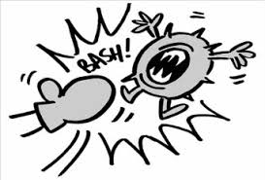](http://www.google.co.uk/url?sa=i&rct=j&q=punching+cartoon&source=images&cd=&cad=rja&uact=8&ved=0CAcQjRw&url=http://www.landoverbaptist.net/showthread.php?t%3D58998&ei=UXRsVcmKLOyu7Ab374GYDQ&bvm=bv.94455598,d.ZGU&psig=AFQjCNFSHsq7ZE63OecfoKVc1nj7_OE--Q&ust=1433257401938719)

* Aggression

**Extraneous Variables:**

**Task: What is an extraneous variable and why is it important to control for them?**

Include the term ‘confounding variable’ in your answer.

**Task: Circle the extraneous variable in each of the following examples then explain how you could control for it to stop it influencing the results;**

1. The researchers were interested in the effects of time of day on memory recall. They put all the young people in the morning condition and all the older people in the evening condition.

1. The researchers were interested in the effects of age on memory recall. They tested all the young people in the morning and all the old people in the evening.
2. Researchers were looking at the effects of noise on concentration. There were two conditions, noisy or quiet. When the researchers were conducting the quiet condition the thermostat broke on the radiator and the room was very stuffy and airless.

**NB: Extraneous variables can also include things such as demand characteristics and investigator effects (more on these later).**

**Control**

The following concepts are involved in keeping research controlled and therefore reliable (can be replicated). In science experiments we have extraneous variables (should be controlled) and this is important so that factors do not become confounding. Only the **Independent variable** (different conditions) should be different for participants (P’s).

**Task: Match up the terms with the correct definitions.**

|  |  |  |
| --- | --- | --- |
| **Random allocation:** |  | Reduces order effects by having half the P’s doing condition A first and half doing condition B first. |
| **Counterbalancing:** |  | The order of conditions experienced is random for each participant. |
| **Randomisation:** |  | All P’s in the study should have exactly the same experiences (apart from the different conditions). |
| **Standardisation** |  | Participants are allocated to one of the conditions randomly so there is no bias of characteristics in a certain condition. |

**Implications of psychological research for the economy**

Economic implications – Effects on the economy e.g. unemployment, business.

Task: Read the research below and make suggestions of economic implications. (HINT think about employment)

Bowlby’s WHO report in the 1950s was taken to suggest that babies needed the constant care of the mother for healthy psychological development. This led to ‘stay at home’ mothering. Later evidence has shown that good substitute care, childcare either in nurseries or by other family members eg father, does not have a detrimental effect on social development of children.

**Reliability and Validity:**

Once a research method has been chosen the researcher needs to consider how useful the data is going to be. The main considerations are whether it will be **reliable** and **valid**.

The term **reliability** refers to how consistent the results are. In other words, if the experiment is repeated, will the same or highly similar results occur again? If the answer is yes, the study can be said to possess high reliability.

**Validity** on the other hand, is whether research measures what it is supposed to.

**Task: Fill in the boxes below to describe the different types of validity.**

Validity

External Validity

Internal Validity

Population Validity

Ecological Validity

[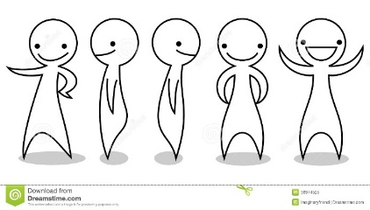](http://www.google.co.uk/url?sa=i&rct=j&q=&esrc=s&frm=1&source=images&cd=&cad=rja&uact=8&docid=fMTb6V9CPXnEFM&tbnid=8SRHeynx6Mx2YM:&ved=&url=http://www.dreamstime.com/royalty-free-stock-photo-cartoon-people-set-smiling-waving-standing-image30974525&ei=jyWYU4HUO6jN7AbOn4G4Bw&bvm=bv.68693194,d.ZGU&psig=AFQjCNEsbLHfufTBwRhDZyUYYkZLJHZ6GQ&ust=1402566416209165)[](http://www.google.co.uk/url?sa=i&rct=j&q=&esrc=s&frm=1&source=images&cd=&cad=rja&uact=8&docid=lmH-KFcdifa3oM&tbnid=9nnRwHyG16qNlM:&ved=0CAUQjRw&url=http://en.wikipedia.org/wiki/The_Real_World&ei=i4SZU-zvF6uV7AbQ7oA4&bvm=bv.68911936,d.ZGU&psig=AFQjCNGvX08Qe73tnMIcByxepQinQmbUaw&ust=1402656260563573)

Different factors can reduce the internal validity of a study. **Task: Fill in definitions below**

***Investigator Effects:***

***Example: T****he researcher’s tone of voice suggests the task is too hard so I give up trying to solve a puzzle.*

***Example:***

***Demand Characteristics:***

***Example:*** *I am aware that the researcher expects me to do poorly in the recall task so I don’t really bother****.***

***Example:***

***Social Desirability effects:***

***Example;*** *I want the researcher to think I’m a good parent so I lie on the questionnaire about how much TV my child watches.*

***Example;***

Both of these potential threats can be controlled using either a **single** or **double** **blind** technique. **Task: Complete explanations below.**

* In a **single blind** technique
* In a **double blind** technique

There are ways to check the reliability of research. **Task: complete definitions.**

**Split half method:**

**Test re-test:**

**Role of peer review**

Peer review is a process after research has been conducted to assess the validity of it, before it is published. It is reviewed by psychologists not involved in the research, but working in a similar field.  
  
Peer review is important because:

* It is a way of making a judgement about the validity, originality, quality and importance of the research before publication.
* They also judge the significance of it in a wider context
* They assess whether methods and designs used are appropriate.
* They can share their opinions on whether they believe it should be published in its original form or changed in some way by suggesting recommendations or future improvements to ensure once it is published it is well-respected.

However some problems surround peer review:

* Bias, work consistent with current theory is more likely to be accepted.
* Reviewers own beliefs may be biased as to the outcomes of the research.
* The ‘file drawer effect’, which is where research supporting the null hypothesis is less likely to be supported.

**Task: Choose one piece of information from each list above (one positive and one negative) and expand on the points made.**

**Ethical Issues and the BPS**

**Task: Follow this web link and use the document to answer the following questions.**

**https://www.bps.org.uk/who-we-are**

1. What do the letters BPS stand for?
2. What are the BPS and what are some of the things they do?

The BPS are responsible for providing guidelines which researchers must follow when carrying out research. These are explained on the website below.

<https://www.simplypsychology.org/ethics.html> use it to complete the table.

|  |  |  |
| --- | --- | --- |
|  | **Explain each issue** | **How would you deal with the issue?** |
| 1. Deception |  |  |
| 1. Informed consent |  |  |
| 1. Protection of Ps from harm |  |  |
| 4.Confidentiality |  |  |
| 1. Privacy |  |  |
| 1. Right to withdraw |  |  |

**[](http://www.google.co.uk/url?sa=i&rct=j&q=&esrc=s&frm=1&source=images&cd=&cad=rja&uact=8&docid=3Brh-1s38eqWPM&tbnid=KxVlxTS0bEMXJM:&ved=0CAUQjRw&url=http://www.addictedtosaving.com/daily-recap-thursday-5114/&ei=tKKQU8PfO8TX7AayrYGYCg&bvm=bv.68235269,d.ZGU&psig=AFQjCNGnLXU00QEvCaSbHl3xiaqao2e6hw&ust=1402074081169713)Now take some time to read back over your notes. Make a list here of any questions you have for your teacher/peers to help you with.**

Self-evaluation – how do you feel about this section?

|  |  |  |
| --- | --- | --- |
| **Areas I understand fully** | **Areas I don’t understand fully** | **What I will do about it** |
|  |  |  |

**Data Analysis and Presentation**

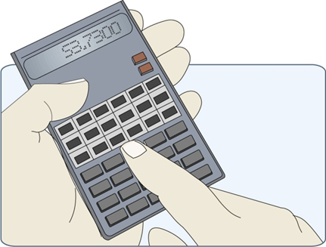

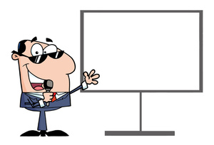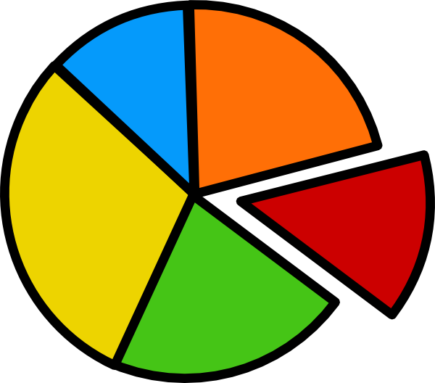

***Section C***

My section C test mark is;

**Quantitative & qualitative data**

Quantitative = numerical data. E.g. number of cats owned.

Qualitative = non-numerical, descriptive data. E.g. thoughts/emotions.

**Task: Fill in the table below with research methods from section A.**

|  |  |  |
| --- | --- | --- |
| **Research method** | **Quan/qual/both** | **Example** |
| **Laboratory experiment** |  |  |
| **F** |  |  |
| **N** |  |  |
| **Ob** |  |  |
| **Q** |  |  |
| **I** |  |  |

**Primary & secondary data**

Primary data = collected from first-hand experience. E.g. own research.

Secondary data = already published elsewhere. E.g. websites/books.

A common use of secondary data is when carrying out a meta-analysis.

**Task: Complete the information below:**

A meta-analysis is

One advantage of this method is

One disadvantage of this method is

**Descriptive Statistics**

Measures of central tendency tell the researcher where the average is in a set of data. The three measures of central tendency you need to know well are the **mean, median** and **mode.**

**TASK: Complete the sentences below:**

1. The me________ is known as the av ___________. It is calculated by adding up all the scores in a set of data and then di___________ them by the total nu___________ of scores.
2. The m___________ is the middle value of a data set. It is calculated by putting the data in o_______ and finding the m________ score. If there is an e_____ number of scores, you should add the two middle scores together and d__________ by t____.
3. The m_______ is the most f___________ occurring score. It is the easiest to calculate – simply put your data in o________ and work out which one occurs the m__________

**TASK: Calculate the mean, median and mode for the following:**

1a) Data from a psychology quiz: 1,2,3,7,10,20,30,43,47,48,7,50.

**Mean = Median= Mode=**

1b) The number of faces recalled in a free recall task: 1,1,5,2,7,6,5,2,1,8,7,9,4,3,2,2.

**Mean= Median= Mode=**

1c) Scores on a questionnaire. 20,30,25,16,13,14,25,26,28.

**Mean= Median= Mode=**

**TASK: Advantages & weaknesses of each measure of central tendency**

|  |  |  |
| --- | --- | --- |
| Mean  +ve  -ve | Median  +ve  -ve | Mode  +ve  -ve |

Researchers may also want to work out how much **variation** there is in a data set. This is known as a **measure of dispersion.** One measure of dispersion is the **range.** This incredibly easy method involves subtracting the lowest score from the highest score.

**Q: What is the range for the following data sets?**

1. 5, 4 ,1, 2, 1, 2, 3, 4, 5, 6, 8, 7, 2.
2. 9, 11, 16, 4, 6, 17, 22, 35, 2, 12, 13.
3. 3, 4, 5, 8, 11, 14, 12, 16, 1, 9, 15, 17.

## Standard Deviation

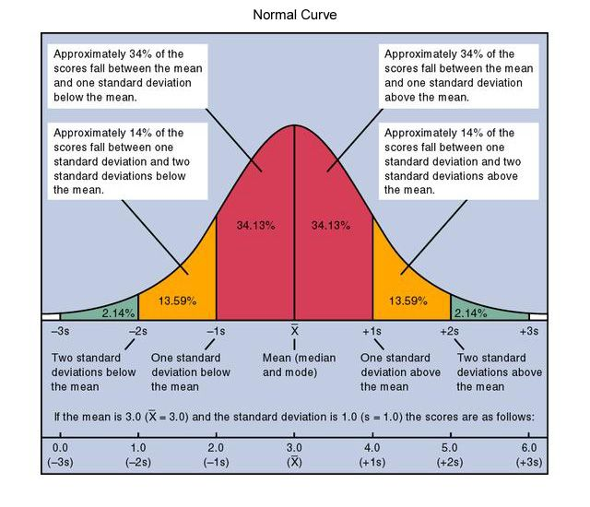Standard deviation is the measure of **the spread of scores around the mean** (i.e. it tells us how far each score is from the mean). **Advantage: It is the most powerful measure of dispersion as it takes all scores into account. Disadvantage: May hide extremes of data.** Below is an example of how a standard deviation might look.

You don’t have to calculate a standard deviation, but you may be asked what the standard deviation tells you about a set of data or why it is used.

* If the standard deviation is **large/small** it tells us that many of the data points are far away from the mean.
* If the standard deviation is small, it tells us that the data **was/was not** clustered around the mean.

**Task: Calculate the % for the following:**

**TASK:** **Explain how to calculate %** (if unsure try this link) http://www.ehow.com/how_10014589_calculate-percentage-something-set-data.html

1. You scored 14 out of 16 in a psychology test.
2. You ate 5 chocolates from a bag of 60.
3. You save £5 off a £25 top.
4. You drink 10ml from a 250ml drink.

**Correlational Analysis**

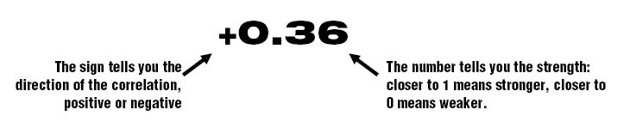Correlations are designed to investigate the **strength** and **direction** of a relationship between two variables. The strength of this correlation is expressed by the **correlation coefficient**, always between **+1** (a perfect positive correlation) and **-1 (**a perfect negative correlation). A correlation coefficient of 0 means that there is no correlation. Under 0.5 generally means the correlation is not significant (though this depends on amount of data).

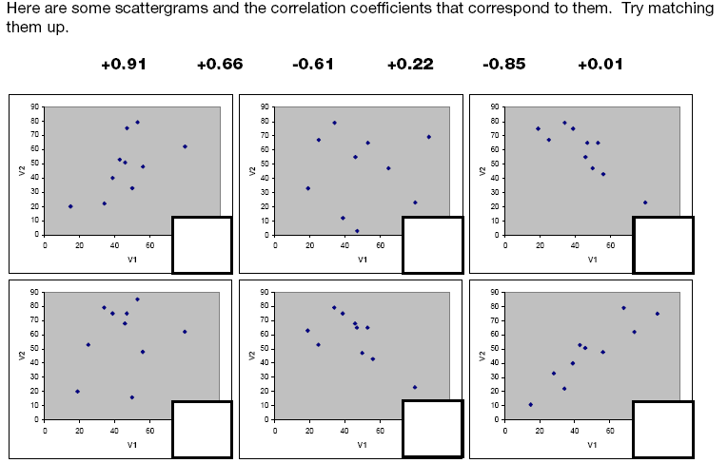

A researcher wanted to find out the relationship between the number of hours a child spent in day care and their level of aggression.

**Task; Plot the following data on the graph paper below.**

|  |  |  |
| --- | --- | --- |
| Participant | Number of hours in day care per week | Score on aggression scale |
| 1 | 30 | 45 |
| 2 | 35 | 48 |
| 3 | 10 | 12 |
| 4 | 35 | 40 |
| 5 | 30 | 28 |
| 6 | 6 | 6 |
| 7 | 8 | 10 |
| 8 | 15 | 20 |
| 9 | 40 | 48 |
| 10 | 20 | 25 |



**Q; Does the scattergram show a negative or positive correlation. Explain.**

**Q; Is the correlation strong or weak? Explain.**

**Q; Write a conclusion for this data.**

**Summarising Quantitative Data**

You must be able to present and interpret tables and graphs.

**TASK**: For each example describe what the data is showing and draw conclusions.

**Table 1**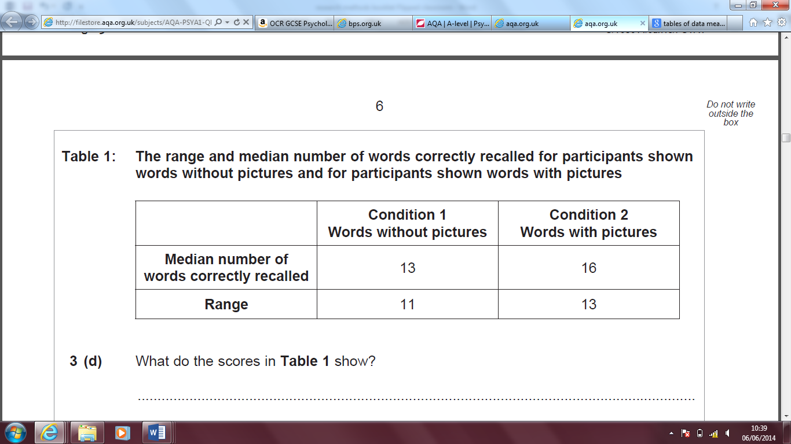

Table 1 shows that ……..

We can conclude that ………………………

**Table 2**

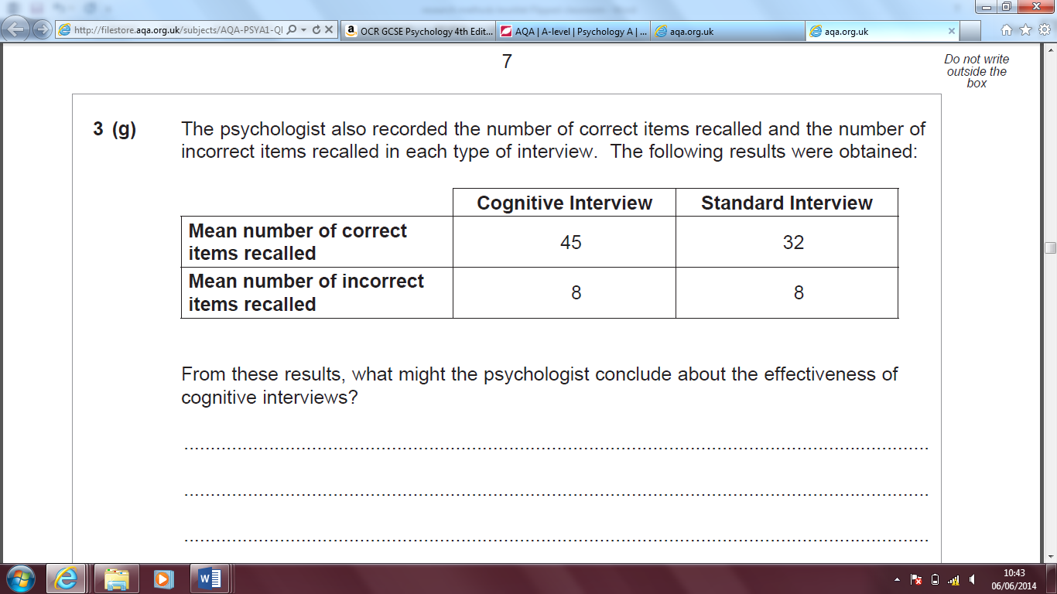

Table 1 shows that ……..

We can conclude that ………………………

**Summarising Quantitative Data *(in graphical form)***

Graphs enable psychologists to easily see trends or patterns in data.

Task; Complete the notes for each graph below and explain when each is likely to be used.

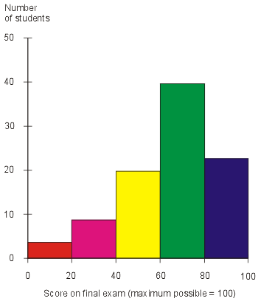**Histograms**

**Notes:**

**This graph is likely to be used when:**

**Notes:**

This graph is likely to be used with **continuous/discontinuous** data.

**[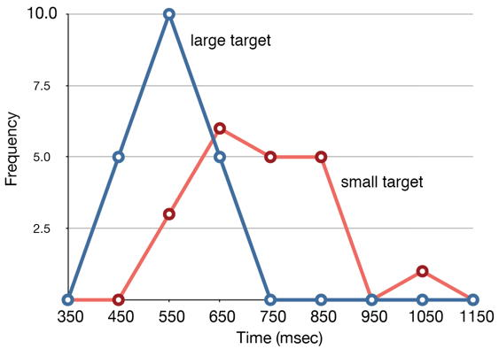](http://www.google.co.uk/url?sa=i&rct=j&q=&esrc=s&frm=1&source=images&cd=&cad=rja&uact=8&docid=M_dtoep1SpH_sM&tbnid=w2aqgT1seL4tNM:&ved=0CAUQjRw&url=http://onlinestatbook.com/2/graphing_distributions/freq_poly.html&ei=_DyYU77qOq6p7Aajt4CwBg&bvm=bv.68693194,d.ZGU&psig=AFQjCNHPPf4MO2BfNCTYM8Hu3VWGG4ALgw&ust=1402572334423325)Frequency Polygons**

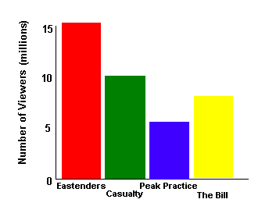

**Notes:**

This graph is likely to be used with **continuous/discontinuous** data.

**Bar chart**

[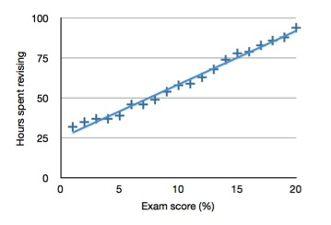](http://www.google.co.uk/url?sa=i&rct=j&q=&esrc=s&frm=1&source=images&cd=&cad=rja&uact=8&docid=rq3PVk8xMtQdHM&tbnid=PHPgV6rtYPQXPM:&ved=0CAUQjRw&url=http://www.psychteacher.co.uk/research-methods/correlations.html&ei=wzaYU-yhJ7SB7QaJ3YDIBQ&bvm=bv.68693194,d.ZGU&psig=AFQjCNFWJ2w5zrYwVfCKZlc2jmkXnaBPJQ&ust=1402570809379386)**Scattergrams**

**Notes:**

**This graph is likely to be used when:**

**Task: Fill in the gaps below;**

1. The bars on a ____________ are joined together and are **all/not all** of an identical width.
2. A histogram is commonly used to show **continuous/discontinuous** data. (e.g. IQ or test)
3. Bar charts are a useful way of showing **descriptive/inferential** statistics (e.g. percentages or ratios).
4. Bars on a bar chart **are/are not** touching because the scale is not **continuous/discontinuous**.
5. Scattergrams are used to show the **misdirection/direction** and **strength/power** of correlations.

**Distributions**

**[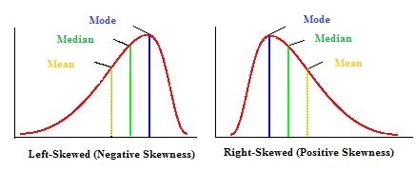](http://www.google.co.uk/url?sa=i&rct=j&q=skewed+distributions&source=images&cd=&cad=rja&uact=8&ved=0CAcQjRw&url=http://www.statisticshowto.com/skewed-distribution/&ei=32BwVeP5OKXD7gaAjYKIBg&bvm=bv.94911696,d.ZGU&psig=AFQjCNE-KSRauUKfL45c_wv4z7A7TIiBfQ&ust=1433514583515531)TASK:** Look at the diagram on page 36 and sketch it here – this shows a normal distribution of data.

Normal distribution

Q: How does each type of distribution vary with the highest number of scores in relation to the mean?

**The Sign Test**

Statistical tests are so much fun we will save this for in class – however if you are feeling adventurous feel free to have a look on the web at what it involves.

**Levels of data**

The type of data your investigation collects will affect which measures of central tendency and dispersion you can use so it is important to recognise them.

|  |  |  |  |
| --- | --- | --- | --- |
| **Nominal** | **Ordinal** | **Interval** | **Ratio** |
| Categories | Ranking | Data on a **scale** – intervals are equal and known | Data on a scale, intervals equal and known, with a true **zero** |
|  |  |  |  |
| e.g. | e.g. | e.g. | e.g. |

**Task; Exam Question – June 2011 (modified)**

1. Two different drug therapies were tested on a group of patients. The table below shows the improvement made between the start and end of the treatment. Explain what these findings suggest about the different therapies. (4 marks)

|  |  |  |  |
| --- | --- | --- | --- |
|  | **Average** | **Range** | **Standard Deviation** |
| **Therapy A** | 6.5 | 2 - 19 | 5.9 |
| **Therapy B** | 6 | 4 - 9 | 7.8 |

____________________________________________________________________________________________________________________________________________________________________________________________________________________________________________________________

**[](http://www.google.co.uk/url?sa=i&rct=j&q=&esrc=s&frm=1&source=images&cd=&cad=rja&uact=8&docid=3Brh-1s38eqWPM&tbnid=KxVlxTS0bEMXJM:&ved=0CAUQjRw&url=http://www.addictedtosaving.com/daily-recap-thursday-5114/&ei=tKKQU8PfO8TX7AayrYGYCg&bvm=bv.68235269,d.ZGU&psig=AFQjCNGnLXU00QEvCaSbHl3xiaqao2e6hw&ust=1402074081169713)Now take some time to read back over your notes. Make a list here of any questions you have for your teacher/peers to help you with.**

Self-evaluation – how do you feel about this section?

|  |  |  |
| --- | --- | --- |
| **Areas I understand fully** | **Areas I don’t understand fully** | **What I will do about it** |
|  |  |  |

Well done 😊