It is expected that you will keep a log of the work you have completed prior to starting the course.
As well as completing the grammar transition work, please hand in a log of any film, news video, article, song etc… that you have read, watched or listened to.
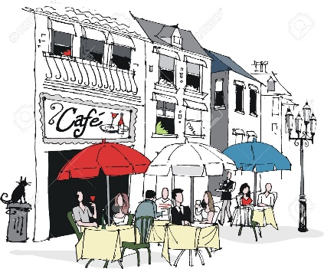
1.Grammar Check
The year 12 courses in French all contain revision of Grammar from the GCSE syllabus. The check list below covers most of these areas. You may like to use your GCSE grammar booklets/notes if you have them or go to www.languagesonline.org.uk for explanations and exercises. If there is anything in this list that you do not recognise, don’t panic – you will cover it in lessons next year. However, you may like to research what it is in advance, just to be prepared.
It is expected that you also complete:
- the transition grammar booklet (page 5 to 11) attached with answers for self-marking .
- the basic GCSE tenses booklet also attached with answers

Nouns, gender, plurals
Articles, partitive, possessive adjectives
Present tense, reflexive verbs, semi-regulars,
High frequency irregulars, irregular verb patterns
Adjectives and their feminine forms
infinitive use and constructions
Negatives
Modals verbs (vouloir/devoir/pouvoir and impersonal verbs (Falloir)
Pronouns - direct, indirect, personal, reflexive
Perfect tense (Passé composé)
Pronouns y, en, emphatic/ disjunctive, relative, possessive, demonstrative
Adverbs
Forming questions,
Present participle
Use of depuis
Imperfect (Difference between Perfect and Imperfect use).
Future and conditional tenses and their irregular stems.

2.Cultural background
Having an idea of the cultural background of France and the French speaking world is crucial for this course. We suggest you do the following in preparation for the course:

- Read a French magazine or newspaper or watch a podcast. Inner French is available on Spotify
Episodes (innerfrench.com) and is a fantastic way to improve your listening skills!
On You Tube, you could follow Hugo decrypte who does little videos on current affairs in France
- Watch a French film (with English subtitles). Netflix has a good selection of current, modern French films and series which provide a fantastic insight into modern France and issues in French society today. You could also find out about the Cannes festival in France and the films which have won awards in the last few years.
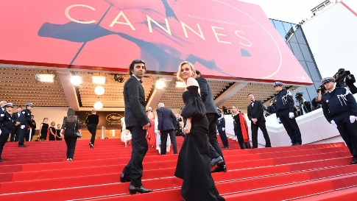
The Festival de Cannes is a major event in France. It takes place every year in May and is a reflection of French people’s love of cinema. It features film makers from all over the world.
Suggestions:
Call my agent (series)
Divines
Les petits mouchoirs
The parisan agency (series) on Netflix
Lupin (series)
Bienvenue à Marly-Gomont
Il a déjà tes yeux
La vie scolaire
Intouchables

- Read a French novel. (We have some of the below in the school library).
Some accessible titles are:
Monsieur Ibrahim et les fleurs du Coran or Oscar et la dame rose. (Eric-Emmanuel Schmitt)
La vie devant soi (Romain Gary)
Short stories in French (Olly Richards and Richard Simcott)
Bonjour tristesse (Françoise Sagan).
No et moi (Delphine de Vigan)
On Amazon, you can find a range of “parallel texts”, French short stories in both French and English. These are very useful as you can see the translation into English on the opposite page.

- Listen to some French songs in preparation for the topic on France’s musical heritage. Download our Spotify playlist and search the lyrics to the songs:
https://open.spotify.com/playlist/1thho5e4EtoVSjXitAlgmE?si=wJE0lth6QI-uEqmetmf-hA

Please go to the next page for an overview of the specification :

3. Overview of the Edexcel AS syllabus
There are 4 big themes covered during the 2-year course. Below is the detail of what you will cover in the first year.
Translate the headings and sub-headings into English for yourself.
Start by researching articles online by entering the key words into google.fr.
A minimum expectation is that you will have looked up at least one article on each of the sub-sections and kept a glossary of any vocabulary you have looked up.

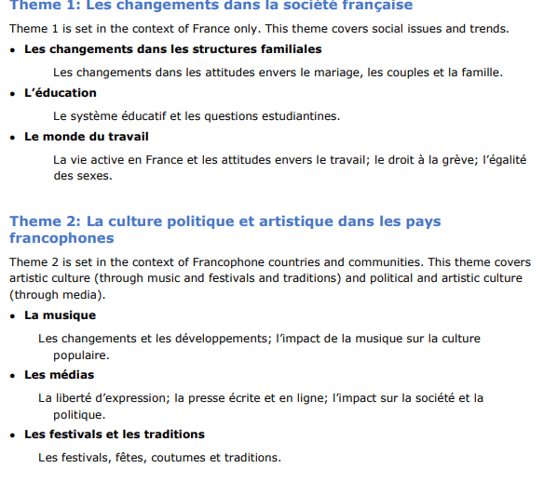

Bonnes vacances et à bientôt en septembre!

